A MULTI-CRITERIA STUDENT-TUTOR MATCHMAKING SYSTEM USING WEIGHTED SCORING AND AVAILABILITY OPTIMIZATION
A Final Year Project Presented by
ANUMUDU UDOCHUKWU SAMUEL
20211259202
AND
OBI MICHAEL CHIMAOBI
20211265722
Submitted to
THE DEPARTMENT OF SOFTWARE ENGINEERING
SCHOOL OF INFORMATION AND COMMUNICATION TECHNOLOGY
FEDERAL UNIVERSITY OF TECHNOLOGY OWERRI
Supervised By
Engr. Dr. A. I. Erike
IN PARTIAL FULFILLMENT OF THE REQUIREMENTS FOR THE AWARD OF
BACHELOR OF TECHNOLOGY (B. TECH) IN SOFTWARE ENGINEERING
JULY 2026

ABSTRACT
Student-to-tutor matching is a multi-criteria decision-making problem, but most tutoring platforms base their matches on subject and availability only. This paper designed, implemented and tested a multi-criteria student-tutor matchmaking system in the context of secondary school tutoring environments. Compatibility is determined using a composite scoring function with four bounded sub-score functions (academic, preference, scheduling, and fairness) aggregated using weights chosen by students, while the matchmaking is performed using a greedy algorithm with lazy fairness recompute using a priority queue and a bounded repair pass, implemented as a framework-agnostic TypeScript domain layer in a NestJS/PostgreSQL web application. The time complexity of the algorithm is O(n² log n), demonstrated empirically by quadratic growth of the number of pairs scored when scaling up five times, as well as by achieving 97.6-100.0% of the optimal total score against a min-cost max-flow baseline. The classical 1/2-approximation guarantee belongs to the static greedy matching step alone and does not extend to the deployed engine, which adds fairness to the priority function, top-K truncation, deterministic hash tie-breaks and the bounded repair pass; its quality is therefore established by measurement rather than by that bound. Adding a fairness weighting term moved Jain’s fairness index by +0.0065 to +0.0288 across the contested 1.5:1 to 3:1 band and left it unchanged at 10:1, where tutor capacity alone fixes the load vector; the accompanying change in average match quality is a weight renormalisation artifact rather than a cost. The worst-placed match was bounded exactly as well: the largest floor at which every student is still assignable exceeds the engine’s own worst placed pair by 0.0075 to 0.0241 in every scenario, and an exact assignment under that floor lifts the worst placed pair with no loss of total or coverage (30 of 30 populations, p < 0.0001).
Keywords: student–tutor matching; multi-criteria decision-making; weighted scoring; greedy assignment; fairness; explainability
Table of Contents
ABSTRACT 2
CHAPTER ONE 6
1.1 Background to the Study 6
1.2 Statement of Problem 7
1.3 Objectives of the Study 8
1.4 Research Questions 9
1.5 Scope of the Study 9
1.6 Limitations of the Study 10
1.7 Significance of the Study 10
1.8 Definition of Terms 10
CHAPTER TWO 12
2.1 Conceptual Framework 12
2.2 Theoretical Framework 13
2.3 Empirical Framework 14
Research Gap 15
2.4 Summary of Literature Review 15
CHAPTER THREE 17
3.1 Requirements Gathering 18
3.2 Developing an Algorithm to Match Students with Tutors Based on Established Criteria 21
3.3 Implementation Plan 23
CHAPTER FOUR 25
4.1 Analysis of Data Collection 25
4.1.1 Hardware and Software Stack 25
4.2 System Architecture 26
4.2.1 Three-Tier Architecture 27
4.2.2 Core Algorithm Architecture (Domain Layer) 28
4.3 Database Design 30
4.3.1 Schema Design 30
4.4 Module Design 32
4.4.1 Backend Module Architecture 32
4.4.2 Consumption of the Matching Endpoint 34
4.5 Algorithm Design and Complexity Analysis 34
4.5.1 Composite Scoring Model 34
4.5.2 Priority-Queue Greedy Assignment Algorithm 36
4.5.3 Time Complexity Analysis 41
4.5.4 Space Complexity Analysis 42
4.5.5 Empirical Validation Against the True Optimum 43
4.6 Key Edge Cases and Their Handling 44
4.7 Implementation 45
4.7.1 Core Algorithm Implementation 45
4.7.2 Key Code Snippets 46
4.8 Module Implementation 48
4.8.1 Matchmaking Flow (End-to-End) 48
4.9 Testing Strategy 51
4.9.1 Unit Testing Approach 51
4.9.2 Edge Case Verification 53
4.9.3 Test Execution 54
4.10 Results and Evaluation 54
4.10.1 Evaluation Harness 54
4.10.2 Match Quality and Fairness 55
4.10.3 Effect of the Fairness Weight 56
4.10.4 Performance Benchmarking 57
4.10.5 Comparison with Baseline Assignment Strategies 58
4.10.6 Explainability 60
4.11 Discussion 60
CHAPTER FIVE 62
5.1 Summary of Findings 62
5.2 Conclusions 63
5.3 Recommendations 65
5.4 Contribution to Knowledge 65
5.5 Future Work 66
REFERENCES 67
APPENDIX 71
Appendix A: Source Code 71
Appendix B: Corrections Log (Seminar Proposal to Implemented System) 71
Appendix C: Provenance of the Test Suite and Evaluation Figures 75

LIST OF FIGURES
Figure 2.1: Conceptual framework of the matchmaking pipeline 14
Figure 3.1: Simplified flowchart of the criteria-based matching procedure (design overview) 41
Figure 4.1: Use case diagram of the matchmaking system 29
Figure 4.2: Core UML package diagram 30
Figure 4.3: Class diagram of the core domain 32
Figure 4.4: CrowsFoot ERD 33
Figure 4.5: UML component diagram 35
Figure 4.6: Detailed flowchart of the priority-queue greedy assignment 43
Figure 4.7: Sequence diagram of the end-to-end matchmaking flow 50
Figure 4.8: Activity diagram of the end-to-end matchmaking flow 53

CHAPTER ONE
INTRODUCTION

1.1 Background to the Study
Online learning has now become mainstream. The online tutoring services market alone, for instance, was estimated at USD 10.4 billion in 2024 and is forecast to almost double, to reach USD 23.7 billion in 2030 (Grand View Research, 2025), with students at the primary and secondary levels contributing over half of that demand. The increased popularity of learning services is due to the rising adoption of a broader trend in learning personalization – learning tailored to the unique needs and learning styles of each individual learner. This trend has been widely recognized in studies of educational recommender systems and is directly correlated with higher levels of engagement and better educational outcomes (Deschenes, 2020; da Silva et al., 2023; Spivakovsky et al., 2025).
The need for quality additional tutoring can be seen in the context of the West African secondary schools where the current research project is set up. According to WASSCE results of 2024, out of 1.8 million candidates, 72.12 percent scored credit passes in at least five subjects, including English Language and Mathematics, but this is a drop of 7.69 percentage points compared to the 2023 results (Vanguard, 2024). That left roughly half a million candidates without credit passes in at least five core subjects. Many others are working to improve their grades for competitive university admission, and hiring a private tutor for WAEC and NECO preparation has become the standard response. However, this process is still largely informal, with most people relying on recommendations from others and online sources.
Even where tutoring websites are available, the process of matching students with tutors is done using very primitive techniques such as manual assignment, keyword filtering, or even rules based on subject and availability only (Taveekarn et al., 2014; Ramesh, 2020). While this may be easy to implement, it does not consider various aspects that make up the suitability of a match, which includes subject expertise and proficiency level, tutor experience, language, schedule fit, teaching style compatibility, cost, and history of the tutor. Unsuccessful matches end up wasting hours of contact and even money for the paying family.
Besides this, there are issues of imbalances that occur within the platform since most of the tutors who are highly ranked have too many students to teach while the new tutors have none at all due to the ranking effect (Pitoura et al., 2022), and there are also clashes in schedules. Multi-criteria decision-making and combinatorial optimization provide an elegant solution to the two issues since they use the weighted scoring models to evaluate and solve conflicting constraints and even fairness constraints (Wang et al., 2023; Hien et al., 2025). This paper will use this approach to tackle the issue of matching of tutors and students in a system implemented using NestJS, React and PostgreSQL.

1.2 Statement of Problem
Online tutoring has grown into a large market, yet the core question of which tutor a student gets assigned to is still settled by methods the literature has already shown to be inadequate. Tutor-finder platforms match on subject and time slot and little else (Taveekarn et al., 2014). Some allocation algorithms bring in teaching style but leave scheduling and fairness out (Ramesh, 2020), and surveys of educational recommender systems note how rarely direct tutor allocation is attempted at all (da Silva et al., 2023). The situation gives rise to a set of concrete problems:
- Limited matching criteria: Current systems ignore important factors such as teaching style, language compatibility, pricing, and historical performance.
- Scheduling conflicts. A tutor’s calendar and a student’s calendar often fail to overlap, and the problem repeats week after week for anyone on a regular schedule.
- Uneven tutor workload. A few well-known tutors get flooded with requests while the rest sit idle, so demand piles up unevenly.
- Rigid preference handling. Most platforms apply the same criteria to every student and never adjust for personal priorities, such as how much price matters or a preference for experienced tutors.
- Weak conflict handling. Cancellations, reassignments, and two students competing for the same slot are dealt with poorly or not at all.
Every group involved feels the cost of these gaps. A student revising for an important exam can lose days to the search for a tutor. A family that takes on an unsuitable tutor ends up paying twice when the tutor has to be replaced, while tutors on the other side see fewer bookings simply because demand is spread unevenly. For the platform itself, an opaque matching process erodes users’ trust in the recommendations it makes. The literature reviewed in Chapter Two turned up no study that brings multi-criteria decision-making, timetable feasibility, workload balancing, and explainable matching together in a single student-tutor allocation framework, and closing that gap is what this project sets out to do.

1.3 Objectives of the Study
General Objective
To build and assess a multi-criteria student-tutor matchmaking algorithm that improves compatibility, fairness, and scheduling efficiency in digital tutoring settings.
Specific Objectives
The study aimed to:
- To define a weighted composite score for student-tutor compatibility that draws on subject expertise, grade level, experience, teaching style, price, and region, with each sub-score kept within [0,1].
- To give each student control over how much weight every matching criterion carries, renormalising the weights automatically after any change.
- To develop a conflict-resolution mechanism for competing tutor requests and overlapping schedules, including deterministic tie-breaking and waitlisting.
- To implement a fairness and load-balancing mechanism that distributes students equitably across tutors, and to identify the operating conditions under which it is effective.
- To evaluate the algorithm’s computational efficiency and scalability through formal complexity analysis and empirical benchmarking, and its match quality against an exact optimal baseline.
- To integrate the algorithm into a full-stack web application demonstrating the end-to-end matchmaking workflow.

1.4 Research Questions
No. | Research Question
RQ1 | How can a multi-criteria weighted model be designed for student–tutor matching?
RQ2 | How can student preferences be dynamically incorporated into the matching process?
RQ3 | How can scheduling constraints and availability conflicts be resolved efficiently?
RQ4 | How can fairness and tutor load balancing be implemented in the system?
RQ5 | How can historical performance metrics improve match quality?
RQ6 | How scalable is the proposed algorithm compared to traditional matching methods?
RQ7 | How can explainability be integrated into the matchmaking process?

1.5 Scope of the Study
The current study considers the design, implementation and evaluation of a multi-criteria matchmaking system for secondary school tutoring that uses weighted compatibility scores, schedule matching and subject, grade level and examination type (WAEC, NECO etc.) preferences filtering. Examination type is not used as a background notion but is implemented in the system explicitly. It is stored as an attribute of students and tutors (Section 4.3.1), taken into consideration at the eligibility filtering stage (Section 4.6) and affects the calculation of the academic compatibility score (Section 4.5.1). Evaluation of the system also involves realistic secondary school data from Nigeria (Section 4.10.1). The system also implements workload balancing and explains every match.
Technically, the study considers the implementation of the weighted scoring model, scheduling constraints handling, student-tutor conflict handling, and system evaluation for fairness, scalability and performance. The implementation of the system uses the three-tier architecture with the Next.js React frontend, NestJS backend where matchmaking algorithm is implemented in the domain layer of the system and PostgreSQL database managed via Drizzle ORM.

1.6 Limitations of the Study
- The system was analyzed using simulated data sets instead of actual large-scale data from the platform.
- Behavioral aspects of humans such as personality compatibility and emotional interaction are missing in the model.
- The performance analysis depends upon the nature of the feedback data, which may be biased or incomplete.
- Fairness here is defined by a fixed mathematical formula, which is not necessarily how users experience it in practice.
- The 1/2-approximation guarantee applies to the static greedy matching step alone, not to the deployed engine, which adds fairness to the priority function, top-K truncation, deterministic tie-breaks and a bounded repair pass; its solution quality is therefore established by measurement (97.6-100% of the exact optimum at the scales tested) rather than by that bound.

1.7 Significance of the Study
The work matters because it pairs algorithmic rigor with a genuine educational need. Matching stays fast and accurate, tutor loads remain balanced, and every tutor is assessed on objective data rather than reputation alone.
The study also adds to the theory of multi-criteria optimisation and explainable recommendation. Its complexity analysis, together with the finding that the fairness weight only helps within a specific load band, applies to matchmaking mechanisms in general, and to greedy priority-queue assignment with lazy fairness recomputation in particular.

1.8 Definition of Terms
Term | Definition
Student-Tutor Matchmaking System | An algorithmic system that assigns tutors to students based on multiple criteria.
Multi-Criteria Decision-Making (MCDM) | A method of evaluating options using multiple weighted factors.
Priority-Queue Greedy Assignment | An algorithm that processes the highest-scoring student-tutor pair first using a max-heap, with lazy fairness recomputation to catch stale scores.
Dynamic Weighting | Adjusting the importance of criteria based on user preferences.
Compatibility Score | A numerical value representing the suitability of a tutor for a student.
Hard Constraints | Conditions that must be strictly satisfied (e.g., subject match, grade-level and exam-type support, capacity check).
Soft Constraints | Flexible conditions that influence ranking but are not mandatory.
Load Balancing | Distribution of students among tutors to avoid overloading.
Fairness Score | A load-based score that decreases as a tutor approaches capacity, implemented as min(1, (1 - LoadRatio(t))^1.15 + cold-start boost) (Section 4.5.1).
EMA (Exponential Moving Average) | A weighted average that gives more importance to recent feedback, used for tutor rating updates.
Cold Start | The problem of scoring new tutors with no historical feedback; handled by a neutral default quality of 0.5.
Big-O Notation | A mathematical notation describing the upper bound of an algorithm's time or space complexity.

CHAPTER TWO
LITERATURE REVIEW

2.1 Conceptual Framework
The process of tutor matching has gone through three major phases through history. Initially, tutoring was done manually by the administrator or agency depending on the subject and availability. With the evolution of tutoring software, the process of matching became more sophisticated in the form of simple rules where matching was based only on subject and time slot (Taveekarn et al., 2014). The more recent developments have included additional parameters like teaching method, budget and experience of the tutor, with some weighting but still without any unified mathematical formula and fairness system (Ramesh, 2020). The conceptual model used in this study takes the third phase into account as the pipeline consisting of four interrelated stages of matching, depicted in Figure 2.1.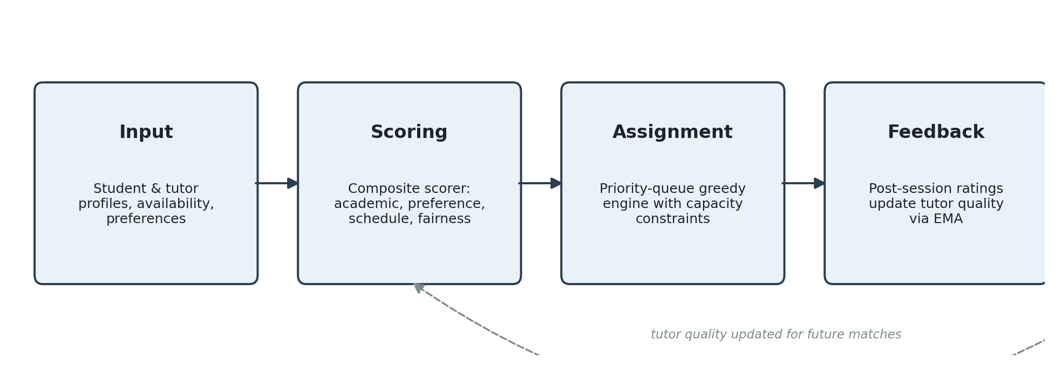
Figure 2.1: Conceptual framework of the matchmaking pipeline
The pipeline’s input, scoring, and assignment stages feed forward, with a feedback loop returning updated tutor quality to the scoring stage for future matches.
The input stage gathers information about students and tutors, namely subject required, academic level, availability, language, tutoring approach, expected payment, and past ratings. Prior work on tutor matching (Taveekarn et al., 2014; Ramesh, 2020) suggests that such profile variables are both feasible and informative.
During the scoring stage, every possible combination of student and tutor gets transformed into the normalized compatibility number based on four composable sub-scorers: AcademicScorer, PreferenceScorer, ScheduleScorer, and FairnessScorer. Each sub-scorer evaluates the pair and returns the value from [0, 1], and then the CompositeScorer combines these values using the four main weights: alpha, beta, gamma, and delta.
In the assignment stage, GreedyAssignmentEngine processes possible matches from high to low score using a max-heap priority queue and lazy recomputation of the fairness score, so that this score reflects the actual tutor load. During the feedback stage, the exponential moving average(ema) with lambda = 0.3 updates the average rating for every tutor after the session.

2.2 Theoretical Framework
Tutor-student assignment is an example of a multi-criteria decision-making problem because the process entails more than one criterion. One can be a better tutor compared to another in terms of subject knowledge but less effective regarding schedule and availability. Multi-criteria decision-making provides a framework for comparing different alternatives through normalization, weighting, and ranking (Wang et al., 2023; Hien et al., 2025). This makes a weighted compatibility score the natural way to decide in this situation, rather than a rule-based filtering approach.
Recommender systems research is also applied in the paper. Traditional literature suggests that recommendations become better in case a coherent framework is built based on user preferences, item properties and ranking algorithms (Adomavicius & Tuzhilin, 2005; Burke, 2002). More recent surveys and handbooks confirm that the recommender systems research field has shifted from algorithm development to user-centered context-aware frameworks (Konstan & Riedl, 2012; Ricci et al., 2022). Here, students are the users and tutors are the items.
The problem becomes even more complex because of the relationship between the quality of the recommendation and the effectiveness of the learning process. Studies by Tarus et al. (2018), Deschenes (2020), and da Silva et al. (2023) apply educational recommender systems to learning materials, peer recommendations, and learning activities, but none of them recommends a personal tutor. Karaci (2019) likewise stresses the value of structured learner modeling and feedback in intelligent tutoring systems, pointing to the need for adaptive algorithms.
Finally, any recommendation should be feasible. In scheduling problems, time overlap, capacity, and ordering of allocation matter most (Leung, 2004; Pinedo, 2022). Feasibility, however, is only part of the problem: modern systems are also expected to be fair and transparent. Pitoura et al. (2022) demonstrate how the ranking systems could result in biased visibility, whereas according to Zhang and Chen (2020), explanation leads to improved trust among users. Coppolillo et al. (2024) also find that the effects of the recommendation could become outdated over time.
The greedy algorithm for the problem studied in this paper relies on bipartite matching theory. It is known that for any weighted bipartite graph, the application of a greedy algorithm on such a graph yields at least half of the optimal value of the total score in virtue of an obvious exchange argument (Korte & Vygen, 2018; Preis, 1999).

2.3 Empirical Framework
Empirical studies related to this topic come from three main directions: educational recommender systems, direct tutor-matching applications, and algorithmic personalization studies. The most relevant studies are summarized in Table 2.1.
Table 2.1: Summary of closely related studies
Study | Focus | Strength | Limitation
Kester et al. (2007) | Learner matchmaking for knowledge sharing | Combines competence, eligibility, and availability | Focuses on learner communities, not tutor allocation
Taveekarn et al. (2014) | Mobile tutor-finding application | Implements direct student-tutor matching | Limited criteria, no fairness or adaptive scoring
Ramesh (2020) | Tutor matching by learning and teaching style | Includes style and level in tutor selection | Narrow scope, no scheduling optimization
Lechuga & Doroudi (2023) | Algorithmic grouping from tutoring data | Uses richer student data for grouping | Addresses peer support, not live tutor assignment
Spivakovsky et al. (2025) | Online tutoring for learning personalization | Confirms individualized support logic | No compact weighted scoring framework
Lotfian & Kabgani (2026) | Multi-objective recommender optimization | Balances multiple objectives simultaneously | Not designed for educational scheduling

Research Gap
Notwithstanding the advancement of knowledge in this area of research, there is still a gap in the literature. Many research papers on educational recommenders target recommendations for learning materials, peer discovery or personalization but not tutor assignment for a particular student. Studies in direct tutor-matching do exist but they mostly rely on limited filters or matching logic without paying due regard to issues of fairness, scheduling conflicts and explainability.
The current paper fills this gap by providing a solution where the weighted scoring with four composable sub-scorers (academic, preference, schedule, fairness) is coupled with a priority queue greedy assignment algorithm with lazy fairness recompute, and feedback-based EMA update in one single implemented framework. The current project has been developed into a full stack application where the algorithm runs as a domain layer.

2.4 Summary of Literature Review
This chapter has shown how student-tutor matching sits at the intersection of three well-established fields of research (multi-criteria decision making, recommender systems, and scheduling), where explainability and fairness are now treated as first-class considerations in system design. Recommender systems for educational content and peer recommendation have advanced quickly in recent years, but student-tutor recommendation remains largely unexplored, and the engines used for it usually depend on simple filters rather than a general multi-criteria weighting framework. The literature also provides the mathematical basis for our design, the proven 1/2-approximation of greedy bipartite matching, which we use directly rather than cite as background.

CHAPTER THREE
RESEARCH METHODOLOGY
Several methodologies are commonly used for software development projects of this kind, including the Structured Systems Analysis and Design Methodology (SSADM), the Object-Oriented Analysis and Design Methodology (OOADM), Prototyping, and Agile development. Each was considered before a final choice was made for this study.
SSADM is a stage-gated methodology that produces extensive documentation before any code is written; it suits projects with fixed, well-understood requirements but adapts poorly when a project’s design changes as implementation reveals new information, as happened repeatedly in this project (Appendix B documents eighteen such changes between the seminar proposal and the final system). OOADM organizes a system around interacting objects and is well suited to systems with rich domain entities, but on its own it does not prescribe how algorithmic components should be revised iteratively once discrepancies are found during coding. Prototyping allows early user feedback on interface mock-ups but does not, by itself, provide a disciplined way to verify that an algorithm’s mathematical properties (such as its approximation guarantee or its complexity bound) hold in the implemented code.
This study adopted a design science approach (Hevner et al., 2004), executed through short, Agile-style iterations, because its central output is an artifact (a matchmaking algorithm and the system that runs it) rather than an observation about an existing system. Design science is appropriate specifically when a study aims to solve a practical problem through the construction of a purposeful solution, which matches this study’s aim of producing both an algorithm and a working implementation of it. Agile iteration was layered on top of the design science process because it allowed each part of the algorithm specification (scoring, assignment, fairness, feedback) to be designed, implemented, tested, and corrected in a short cycle before moving to the next part, rather than committing to a single upfront design that could not be revised once its flaws surfaced during coding.
The overall research process, following the logic proposed by Peffers et al. (2007) for design science research and the staged analysis-design- implementation practice recommended by Sommerville (2016), proceeded in six stages:
- Problem identification and requirements gathering, drawing on the limitations of existing tutor-matching approaches identified in Chapter Two.
- Selection of matching criteria and baseline weights for the composite scoring model.
- System architecture and database design.
- Algorithm specification, expressed as explicit equations with bounded output ranges (Section 4.5), so that each formula could be unit-tested independently.
- Iterative implementation, in which each component was written, checked against the specification, and corrected whenever the code exposed a flaw in the original design, such as an undefined edge case or a formula without a bound. A corrections log was kept through this stage (summarised in Appendix B) so that the reason behind every design change could be traced.
- Evaluation, which covers unit tests, edge-case checks, and empirical benchmarking of the finished algorithm (Chapter Four).
A design science frame shaped the overall research logic, while Agile iteration governed how the algorithm itself changed over time. This pairing was chosen over a single-pass methodology such as SSADM because it allowed corrections without discarding prior work, and over pure Prototyping because it kept the algorithm’s formal properties (bounds, complexity, approximation guarantee) as explicit, testable requirements rather than afterthoughts to the interface.

3.1 Requirements Gathering
The first stage settled what the system had to do and the constraints it had to work within. Requirements were collected through the channels actually open to the study: online sources, questions put to people with relevant knowledge, and a manual run-through of existing practice. This was supported throughout by document analysis of the research literature (Sommerville, 2016; Nuseibeh & Easterbrook, 2000). Online material came first: the websites, product documentation, and market reports reviewed in Chapters One and Two, including the FindMyTutor app (Taveekarn et al., 2014), Ramesh’s (2020) tutor-matching method, the market sizing from Grand View Research (2025), and the WASSCE statistics (Vanguard, 2024). These were examined to see which criteria deployed platforms actually use to pair students with tutors, and where those platforms fall short. Asking questions supplied what written sources could not. The supervisor was consulted during the seminar proposal review of February 2026, and the feedback from that review fixed the intended scope, the matching criteria, and the weighting scheme the study set out to formalise. Informal conversations with fellow students who had arranged private tutoring clarified how families actually choose tutors. Manual examination completed the picture: the authors traced by hand how the traditional manual process, in which an administrator or agency matches students with tutors on subject and availability (Sections 1.1 and 2.1), would assign a small group of students. That exercise is where the fairness and scheduling problems of Section 1.2 first surfaced. Together, these channels defined the problems the system had to address; the research gap distilled from the literature (Section 2.4) then turned them into a concrete specification.
From these sources a set of functional requirements was drawn up. The system must exclude tutors who cannot teach a student’s subject before any ranking happens; score every remaining student-tutor pair on several weighted criteria rather than on subject and availability alone; respect each student’s own preference weights; treat timetable feasibility as a hard constraint; spread students across tutors so that highly rated tutors are not swamped while newer tutors sit idle; fold post-session feedback into a tutor’s standing; and give a reason for every match instead of returning an opaque ranking.
The study’s academic aims also produced a set of non-functional requirements. Each sub-score had to sit inside a known range, so that the composite could be reasoned about and unit tested. The assignment needed to be fast enough to be usable at platform scale, with a complexity bound that could be stated and verified. Figures had to be reproducible from a fixed random seed, so that reported results could be regenerated. The matching logic also had to live apart from the web framework, so it could be tested with no HTTP or database involvement. Table 3.1 lists everything gathered at this stage.

Table 3.1: Requirements gathered and their sources
ID | Requirement | Type | Source
FR1 | Exclude tutors who do not teach the student’s subject, or support the grade level or exam type, before scoring | Functional | Ch. 2 gap; existing systems
FR2 | Score each eligible pair on academic, preference, schedule, and fairness criteria | Functional | Ch. 2 gap
FR3 | Apply each student’s own preference weights to the criteria | Functional | Seminar proposal
FR4 | Treat schedule overlap as a hard feasibility constraint | Functional | Existing systems
FR5 | Balance tutor load so that no tutor is saturated while others are idle | Functional | Ch. 2 gap
FR6 | Update a tutor’s rating from post-session feedback | Functional | Seminar proposal
FR7 | Return an explanation (per-criterion breakdown) for every match | Functional | Ch. 2 gap
NFR1 | Bound every sub-score to [0,1] so the composite is testable | Non-functional | Study aim
NFR2 | Provide a stated, checkable time-complexity bound | Non-functional | Study aim
NFR3 | Make evaluation reproducible from a fixed seed | Non-functional | Study aim
NFR4 | Isolate the algorithm from the web framework for independent testing | Non-functional | Study aim
NFR5 | Authenticate users and separate roles (student, tutor, admin) | Non-functional | Existing systems
The elicitation also settled what data the system would consume and what the evaluation would need. With no live dataset large enough to use (Section 1.6), a domain profile was built from the Nigerian secondary-school context the platform targets: the subjects taught at that level, the grade levels, the WAEC and NECO examination types, representative tutor experience and pricing, and weekly availability patterns. This profile drives the deterministic data generator used throughout the evaluation; Section 4.10.1 describes its design, and Sections 4.10.2 to 4.10.4 analyse the datasets it produces. Locking these fields in during requirements is what let the scoring criteria be defined against real attributes instead of placeholders.

3.2 Developing an Algorithm to Match Students with Tutors Based on Established Criteria
With the requirements fixed, the second stage turned the matching problem into an explicit, computable model. The established criteria, the attributes on which a student and a tutor are judged compatible, were grouped into four buckets, each yielding a sub-score bounded to [0,1]: academic fit, preference fit, schedule fit, and fairness. Every student-tutor pair receives a single composite score, the weighted sum of the four, with the weights summing to one. The full equations for each criterion and for the composite appear in Section 4.5.
Academic fit combines subject depth, graded only after subject eligibility has already been enforced as a hard filter, with grade-level proximity and the tutor’s experience and accumulated rating. Preference fit combines teaching-style similarity, budget compatibility, and, for in-person sessions, regional proximity. Schedule fit is the proportion of a student’s requested time slots that a single tutor slot can cover. Fairness depends only on the tutor, favouring those carrying a lighter load so that assignment is spread rather than concentrated. The baseline weights were set from the relative importance the criteria were given during requirements gathering; a student may override them, after which the weights are re-normalised to sum to one. Table 3.2 lists the baseline criterion weights and the four-bucket weights they aggregate into.

Table 3.2: Baseline criterion weights and the composite buckets they form
Criterion (student-facing) | Weight | Composite bucket
Subject fit | 0.30 | Academic (α)
Experience | 0.15 | Academic (α)
Feedback / rating | 0.10 | Academic (α)
Language / style fit | 0.15 | Preference (β)
Availability | 0.25 | Schedule (γ)
Load factor | 0.05 | Fairness (δ)
Aggregated | α = 0.55, β = 0.15, γ = 0.25, δ = 0.05 | Sum = 1.00
Each component of the model was built in isolation, written as an equation with an explicit output range so it could be unit tested against hand-computed values before being integrated. The full assignment was then cast as a bipartite b-matching problem and solved with a priority-queue greedy algorithm that recomputes each tutor’s fairness lazily as load accumulates during a run, so the fairness term is never stale mid-batch. After each session a tutor’s rating is updated by an exponential moving average, which closes the loop between feedback and later matches. The detailed pseudocode and the complexity analysis are in Section 4.5; the listing below restates the same procedure at the level of design.
Algorithm 3.1: Criteria-based student–tutor matching (design overview)
- For each student, discard tutors who are ineligible on subject, grade level, exam type, or spare capacity.
- Score every surviving pair on the four bounded criteria and blend the results using the student’s weights.
- Push each eligible pair onto a max-heap ordered by its composite score.
- Repeatedly take the best pair. If it is still valid, assign it and raise the tutor’s load. If its fairness score has gone stale, re-push the pair with a fresh score instead of assigning it.
- Put any student who remains unmatched on a waitlist, recording an explicit reason.
- Once a session ends, update the tutor’s rating and use it in later scoring.
Figure 3.1 compresses Algorithm 3.1 into its main flow: eligible pairs are scored on the four bounded criteria, pushed onto a max-heap, and assigned from the highest score downward, each accepted pair raising the tutor’s load before the next is considered. It shows the procedure at design level; the full implementation detail, including lazy fairness recomputation, appears in Section 4.5.2.
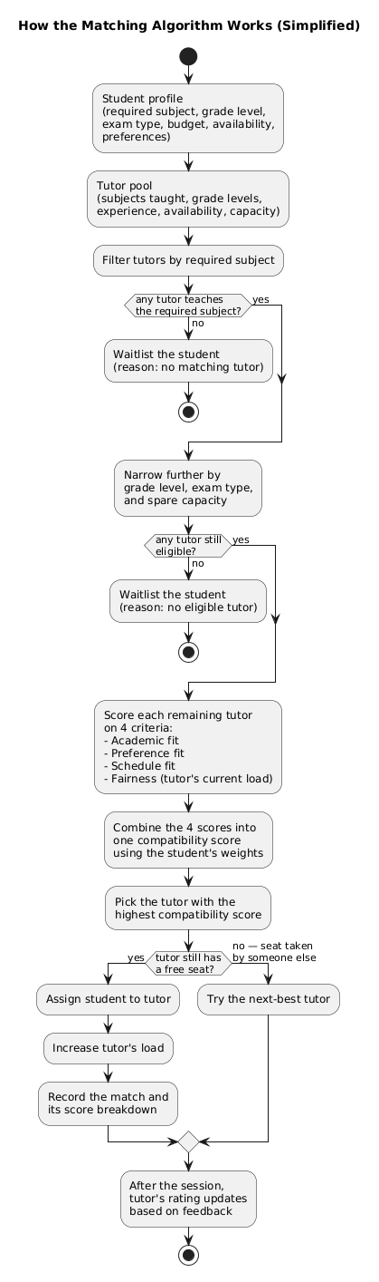
Figure 3.1: Simplified flowchart of the criteria-based matching procedure (design overview)
The greedy engine was not the only strategy formalised. For comparison, the study also built a stability-based alternative: deferred acceptance, the student-proposing Gale-Shapley algorithm (Gale & Shapley, 1962; Roth, 2008) in its college-admissions form extended with tutor capacities, which yields a stable matching in which no student-tutor pair would both prefer each other over their assigned partners. Stability and total score are different objectives, which makes this a genuine competing baseline rather than a tuning variant of the greedy engine. Both strategies run on identical fixtures and are compared in Section 4.10.5, alongside the first-come-first-served strategies that deployed platforms typically use.

3.3 Implementation Plan
The third stage decided how the model would be built, in what order, and how it would be verified. The central choice was to implement the matching logic as a framework-independent TypeScript layer first, free of any dependency on the web framework or the database, and only then to wrap it in the surrounding application. That ordering meant the algorithm could be tested against its specification before any HTTP or persistence code existed.
Implementation was planned in six phases:
- Build the core domain layer (entities, the four scorers, the eligibility filter, the greedy assignment engine, and the feedback updater), each with unit tests asserting exact outputs.
- Set up a standalone evaluation harness with a seeded synthetic data generator based on the domain profile compiled in Section 3.1.
- Expose the core through NestJS feature modules (controllers, services, repositories) over a REST API.
- Store state in PostgreSQL via Drizzle ORM, with migrations generated from the schema.
- Build a Next.js client that exercises the workflow end to end.
- Run the planned evaluation scenarios and write down the results.
The stack was picked to support this ordering. NestJS provides the modular application layer, TypeScript in strict mode gives the typed core, Drizzle ORM over PostgreSQL handles schema-first persistence, Jest covers unit and integration testing, and a pnpm-managed monorepo keeps the backend and the client as separate packages. Section 4.1.1 lists the full stack with its pinned versions.
The plan also defined how the implemented algorithm would be judged. Five metrics were chosen, each tied to a research question from Section 1.4: the average compatibility score of accepted matches (match quality; RQ1, RQ5); the percentage of students left unassigned (allocation effectiveness; RQ3); Jain’s fairness index over tutor loads (load balance; RQ4); wall-clock execution time across dataset scales (scalability; RQ6); and the ratio of the greedy algorithm’s total score to the exact optimum from a min-cost max-flow solver (solution quality; RQ6). Every comparative result is a mean over 30 independent populations with a 95% confidence interval and a paired sign test against the engine, so a difference is quoted only where it separates at p < 0.05; the wall-clock benchmark reports the minimum, mean and maximum across five runs per scale. Two further quantities feed the results rather than the ranking: the static total per student (the load-independent quality measure of Section 4.10.5) and the minimum static score over the pairs a run placed, the worst-placed-student metric introduced in Section 4.10.6. On identical fixtures the engine is also measured against three baselines (Section 4.10.5): filter-only first-come-first-served matching, score-based self-selection, and deferred-acceptance stable matching (Gale-Shapley).
The datasets come from the deterministic generator inside the evaluation harness, seeded so that every figure reported in Chapter Four is reproducible from the repository. Three families of scenarios were planned: a realistic 1:1 case mirroring the seed data, a moderate-load band (1.5:1 to 4:1 student:tutor ratios) designed to probe the fairness mechanism where slack capacity exists, and a 10:1 stress sweep at four scales to check scaling behaviour.

CHAPTER FOUR
SYSTEM DESIGN AND IMPLEMENTATION

4.1 Analysis of Data Collection
The data analysed in this chapter originate in the requirements stage (Section 3.1). With no live platform dataset of sufficient scale available (Section 1.6), the study used two kinds of data. The first kind is the domain profile of the target setting: the subjects offered in Nigerian secondary schools, the grade levels, the WAEC and NECO examination types, representative tutor experience, pricing and capacity, and weekly availability patterns, drawn together from the literature surveyed in Chapter Two and from the seminar proposal. This profile fixes the attributes on which every student and tutor in the evaluation is generated, so the results in Section 4.10 speak to the population the system is designed for rather than to generic random inputs.
The second is the dataset that exercises the system: a deterministic 50-student, 50-tutor seed corpus drawn from that profile (the realistic-seed scenario), together with the synthetic scenario families generated from the same distribution: moderate student:tutor ratios of 1.5:1 to 4:1, and a 10:1 stress sweep at four scales. Section 4.10.1 describes the generator and each family; Sections 4.10.2 to 4.10.5 report the analysis of the data collected at this stage.

4.1.1 Hardware and Software Stack
Layer | Technology | Version | Purpose
Backend framework | NestJS | 11.x | Modular Node.js framework with decorator-based routing, dependency injection, and guards
Language | TypeScript | 5.7 | Strict-mode typed superset of JavaScript used for the backend and the core algorithm layer
ORM | Drizzle ORM | 0.45 | Type-safe SQL-first ORM with schema generation and migrations
Database | PostgreSQL | 14+ | ACID-compliant relational database
Authentication | Passport + JWT | — | Stateless authentication with access and refresh tokens
Testing | Jest | 30.x | Unit and integration testing for the core algorithm layer
Deployment | Render | — | Cloud platform-as-a-service with auto-deploy from GitHub
Table 4.1: Implementation technology stack (algorithm- and backend-relevant components)
A browser-based client was also built to exercise the system end-to-end, but its implementation is outside the algorithmic scope stated in the study title and so is not treated as a subject of analysis here; only the parts of the workflow needed to demonstrate the matchmaking process (Section 4.2) are described.

4.2 System Architecture
Figure 4.1 presents the use case diagram: the actors who interact with the system (student, tutor, and administrator) and the principal functions each performs, from onboarding and requesting a match through to assignment and post-session feedback. How those use cases are realised is described in the rest of this section.
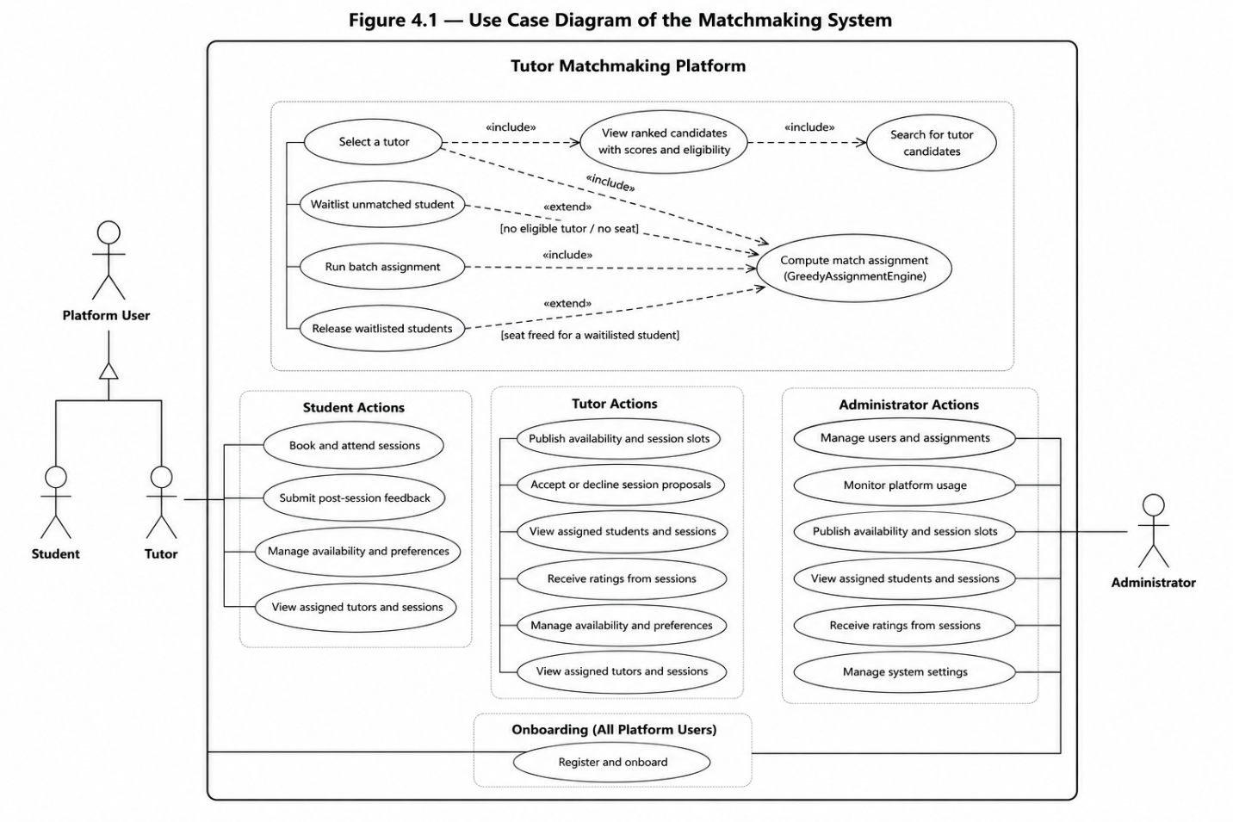
Figure 4.1: Use case diagram of the matchmaking system

4.2.1 Three-Tier Architecture
The system is organised as a three-tier architecture with strict separation of concerns:
- Presentation Tier: a Next.js React single-page application. Students, tutors, and administrators each get role-specific views, including dashboards, tutor discovery, session management, and profile editing. All communication with the backend happens over RESTful HTTP endpoints using Axios with automatic JWT token refresh.
- Application Tier: a NestJS server with ten domain modules, namely auth, users, matchmaking, scheduling, sessions, messages, notifications, feed, dashboard, and a standalone core algorithm layer. The core module is framework-independent; it contains the domain entities, value objects, scoring algorithms, and the assignment engine. The matchmaking module links the core algorithms to the NestJS controllers and repository persistence.
- Data Tier: PostgreSQL holds eight core tables. Drizzle ORM supplies type-safe queries that are validated at compile time, and migrations are auto-generated from the schema definitions.

4.2.2 Core Algorithm Architecture (Domain Layer)
The core algorithm sits in a framework-independent domain layer under src/core/. Nothing in it touches NestJS, Express, the database, or HTTP, which makes it independently testable and reusable. The architecture follows clean architecture principles, with dependency inversion at the repository boundary.
architecture pattern, illustrated in Figure 4.2 below.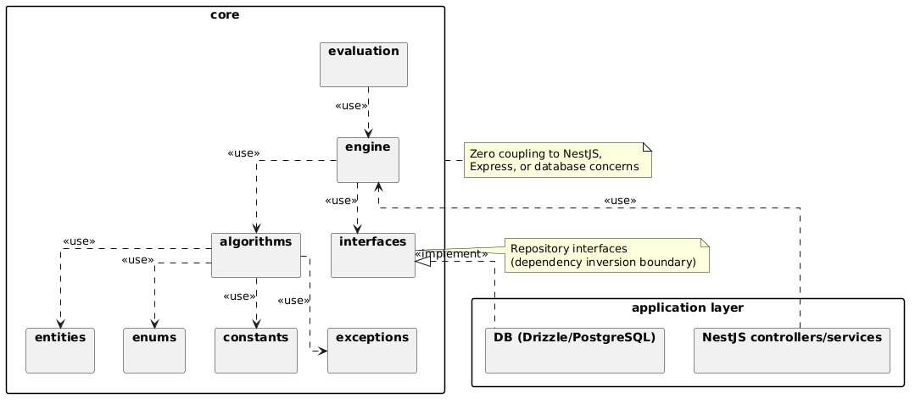
Figure 4.2: Core UML package diagram
Each package is described briefly below
- core/entities/ : holds the domain model (Student, Tutor, Assignment, and related value objects) along with their validation invariants.
- core/algorithms/: contains all scoring, filtering, ranking, and assignment logic, including the scorers, filters, ranker, assignment engine, feedback updater, and supporting data structures (MaxHeap, vector math).
- core/engine/: exposes the MatchingEngine facade, giving the application layer a single, unified entry point into the algorithms.
- core/constants/: centralizes tunable algorithm parameters (e.g. COLD_START_QUALITY, FEEDBACK_LAMBDA, LEVEL_MAX), each traceable back to the design specification.
- core/enums/: defines shared domain enumerations (AssignmentStatus, DeliveryMode, LearningStyle, etc.) used consistently across all layers.
- core/interfaces/: defines the repository interfaces (IStudentRepository, ITutorRepository, IAssignmentRepository) that the outer layer implements: the mechanism behind the dependency inversion shown in Figure 4.3.
- core/evaluation/: provides a standalone harness, including a synthetic data generator, for benchmarking and scalability measurement independent of the production database.
- core/exceptions/: defines domain-specific exceptions (IncompleteProfileException, NoEligibleTutorsException) with explicit, descriptive messages.

Where Figure 4.2 groups the domain into packages, Figure 4.3 gives the class-level design of the core: the principal entities (Student, Tutor, Assignment), the four scorers, the eligibility filter, the greedy assignment engine, and the feedback updater, together with the repository interfaces through which the outer layer supplies data: the relationship that realises the dependency inversion described above.
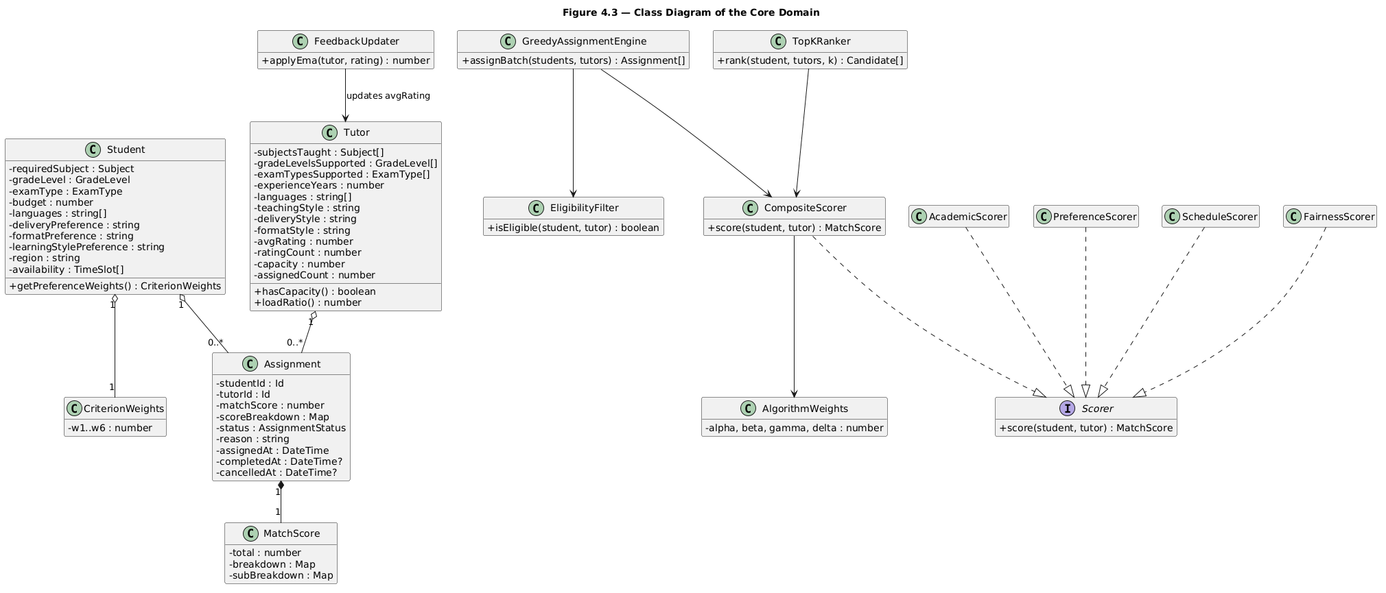
Figure 4.3: Class diagram of the core domain

4.3 Database Design

4.3.1 Schema Design
The database schema follows a normalized design with eight core tables organized around the user entity. The schema is defined in src/database/schema.ts using Drizzle ORM's schema definition syntax. Figure 4.4 shows the entity-relationship diagram for the seven tables that participate in the matching workflow; an eighth (notifications) supports the surrounding application only and is omitted from this discussion.
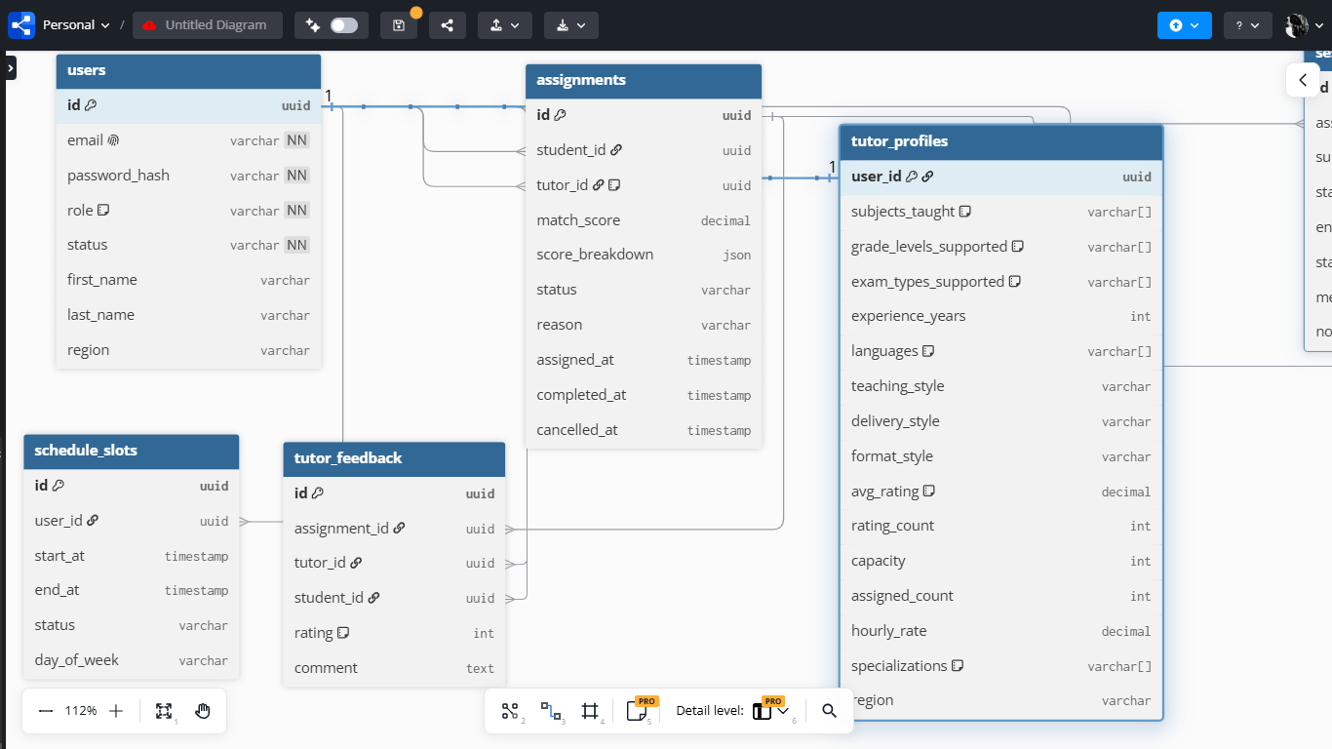
Figure 4.4: CrowsFoot ERD
As shown in Figure 4.4, users sits at the centre of the schema, with student_profiles and tutor_profiles each extending it in a one-to-one relationship, a table-per-role pattern that keeps authentication concerns (email, passwordHash, role, status) separate from role-specific matching data. schedule_slots links back to users to record weekly availability for both students and tutors. assignments is the central match record, referencing users twice, once as the student and once as the (nullable) tutor, and carries the full audit trail of a match, including its computed matchScore and scoreBreakdown. sessions and tutor_feedback both branch off assignments: a completed assignment can produce many scheduled sessions and, separately, feedback records that feed back into a tutor’s exponential moving average rating.
Table | Key Columns | Purpose
users | id (uuid), email, passwordHash, role, status, firstName, lastName, region | Authentication and base identity
Student profiles | userId (FK), subjects[], requiredSubject, gradeLevel, examType, budget, languages[], deliveryPreference, formatPreference, learningStylePreference, region, preferenceWeights (JSON) | Student-specific profile and matching preferences
Tutor profiles | userId (FK), subjectsTaught[], gradeLevelsSupported[], examTypesSupported[], experienceYears, languages[], teachingStyle, deliveryStyle, formatStyle, avgRating (0-1 EMA), ratingCount, capacity, assignedCount, hourlyRate, specializations[], region | Tutor qualifications, availability, and load tracking
Schedule slots | id, userId (FK), startAt, endAt, status, dayOfWeek | Weekly availability schedules for students and tutors
assignments | id, studentId (FK), tutorId (FK, nullable), matchScore, scoreBreakdown (JSON), status, reason, assignedAt, completedAt, cancelledAt | Match records with full audit trail
sessions | id, assignmentId (FK), subject, startAt, endAt, status, meetingUrl, notes | Scheduled tutoring sessions
Tutor feedback | id, assignmentId (FK), tutorId (FK), studentId (FK), rating (1-5), comment | Per-session feedback for EMA rating updates

4.4 Module Design

4.4.1 Backend Module Architecture
The NestJS backend comprises ten feature modules, each following the controller–service–repository pattern. Figure 4.5 shows the five modules that participate in the matchmaking workflow and their dependencies on one another and on the core domain layer; the remaining modules (messaging, notifications, dashboard analytics, and the social feed) provide standard platform functionality with no bearing on the algorithm and are not analysed further, consistent with the scope set in Section 1.5.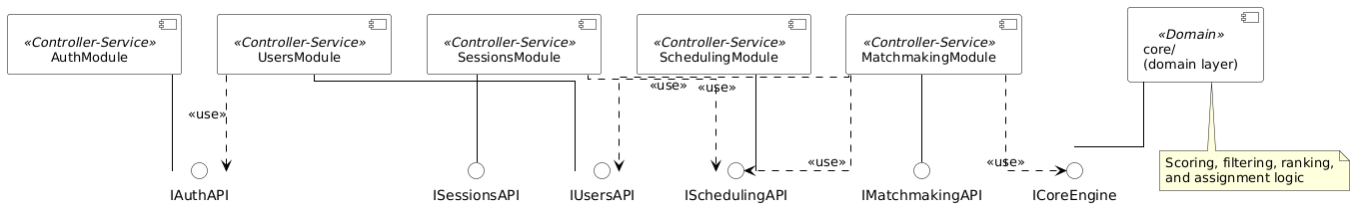
Figure 4.5: UML component diagram
Figure 4.5 shows how each module works: it exposes its functionality through a provided interface and depends only on the interfaces it needs, never on another module’s internals. MatchmakingModule is the hub of the workflow. It calls UsersModule for student and tutor profiles, SchedulingModule for availability slots, and the core/ domain layer described in Section 4.2.2 to build domain entities and run the ranking algorithm. SessionsModule asks SchedulingModule about availability before confirming a booking, and UsersModule relies on AuthModule for the authenticated identity behind any profile request. The result is that all algorithm-facing logic stays in MatchmakingModule and core/, while authentication, profile management, and scheduling remain supporting services.
Module | Controller Endpoints | Responsibilities
Auth Module | /auth/signup, /auth/login, /auth/onboard, /auth/verify, /auth/logout, /auth/refresh | Registration, JWT issuance, role-based onboarding, token refresh
Users Module | /users/:id, /users/me, /users/me/student-preferences, /users/me/tutor-preferences | Profile CRUD and preference management
Matchmaking Module | /matchmaking/candidates, /matchmaking/candidates/students, /matchmaking/select, /matchmaking/batch, /matchmaking/assignments/me, /matchmaking/assignments/:id/status, /matchmaking/assignments/:id/feedback | Scoring, ranking, assignment, feedback ingestion (bridges to core algorithms)
Scheduling Module | /schedules/tutors/:tutorId/slots, /schedules/tutors/:tutorId/sessions | Availability management and time slot queries
Sessions Module | /sessions, /sessions/me, /sessions/:id/accept, /sessions/:id/decline, /sessions/:id/propose | Session booking, lifecycle, and time proposal

4.4.2 Consumption of the Matching Endpoint
A single read endpoint, `GET /matchmaking/candidates`, is how the client reaches the matching engine. On request, the matchmaking service pulls the requesting student’s profile, every active tutor profile, and their schedule slots; builds the corresponding domain entities described in Section 4.2.2; and hands them to the TopKRanker. The response carries the ranked candidates with each tutor’s match score, eligibility status, and score breakdown, which the client shows as a percentage with a per-criterion explanation (Section 4.10.6). No other interaction bears on the matching algorithm. General client concerns, such as authentication, routing, and state management, are standard web-engineering practice and are not analysed further, since they fall outside the scope defined in Section 1.5.

4.5 Algorithm Design and Complexity Analysis

4.5.1 Composite Scoring Model
Everything in the matchmaking system depends on a composite scoring function that gives each student-tutor pair a compatibility score. The scoring function is organised around four buckets:
Equation 4.1: Top-Level Compatibility Score
$$M(s,t) = alpha * A(s,t) + beta * P(s,t) + gamma * S(s,t) + delta * F(t)$$
Where alpha + beta + gamma + delta = 1, and each sub-score is bounded to [0,1].
Equation 4.2: Academic Score A$(s,t)$
$$A(s,t) = w1 * SubDepth(s,t) + w2 * Lvl(s,t) + w3 * Exp'(t)$$
Where $SubDepth(s,t) = Depth(s,t) × ExamFit(s,t). Depth(s,t) = 1.0$ for an exact subject-plus-specialization match, 0.7 when the subject matches but the stated specializations do not align, and 0.5 when the subject matches but specialization data is missing. $ExamFit(s,t) = 1$ when the tutor supports the student’s target exam type (e.g. WAEC or NECO), or when either side leaves it unspecified. An explicit mismatch scores 0.5, so an exam-type clash softens subject depth without ruling out an otherwise capable tutor. $Level compatibility Lvl(s,t) = max(0, 1 - g / Lmax),$where g is the gap between the student’s grade level and the nearest grade level the tutor supports, and $Lmax = 12$. $Experience quality Exp'(t) = theta * min(Years_t / Years_max, 1) + (1 - theta) * Q_t, where theta = 0.4, Years_max = 20, and Q_t defaults to 0.5 for new tutors (cold start).$
Equation 4.3: Preference Score P$(s,t)$
$$P(s,t) = w4 * Style(s,t) + w5 * Budget(s,t) + w6 * Region(s,t)$$
Style$(s,t)$ uses cosine similarity on one-hot encoded vectors representing delivery mode, format preference, and learning style. Budget$(s,t)$ returns 1 if the tutor's hourly rate is within the student's budget, with a linear decay for excesses. Region$(s,t)$ returns 1 for online sessions (where location is irrelevant) and for in-person matches in the same region, 0 for an in-person region mismatch, and a 0.5 neutral default when region data is missing.
Equation 4.4: Schedule Score S$(s,t)$
$$S(s,t) = |Hs ∩ Ht| / |Hs|$$
Here Hs and Ht are the student’s requested and the tutor’s available time slots. For a slot to count, a single contiguous tutor slot must cover it; fragments split across several tutor slots fail the contiguous-slot requirement. A student with zero availability slots is rejected as an incomplete profile.

Equation 4.5: Fairness Score F(t)
$$F(t) = min(1, (1 - LoadRatio(t))^1.15 + b(t)), where LoadRatio(t) = CurrentLoad(t) / Capacity(t)$$
$F(t) = 0 when Capacity(t) = 0 or CurrentLoad(t) >= Capacity(t).$
The exponent 1.15 makes the penalty on heavily loaded tutors slightly more than linear (Appendix B), while b(t) is a cold-start boost of 0.05 that applies only when a tutor has zero assigned students, nudging unused tutors into circulation. By default the load factor weight delta is 0.05.

4.5.2 Priority-Queue Greedy Assignment Algorithm
The assignment algorithm is built on a max-heap priority queue with lazy fairness recomputation, which addresses a known flaw in static sorting approaches: fairness scores go stale once assignments are made. Eligibility (Eligible in Algorithm 4.1) operates as a hard pre-filter. The tutor must teach one of the student's subjects, support the student's grade level and exam type where these are specified, and have spare capacity. Ineligible pairs are never scored and never reach the heap. The heap pass on its own is incomplete: a student can be left unplaced while a seat is held by someone who has an acceptable alternative, because the heap gives each free seat to the best remaining pair and never revisits a decision it has already made. The engine therefore runs a bounded repair pass once the heap has drained (Algorithm 4.1, step 4). For each unplaced student it searches for a depth-bounded augmenting path - move a seated student to a tutor that still has a seat, then repeat - and applies the whole path deepest-move-first when doing so strictly increases the number of placements. The search is deterministic (tutors are explored in static-score order with tutor id as the tie-break, each tutor's holders in student-id order, and students in input order), bounded by a default depth of three displacements plus a per-search work budget, and it never accepts a move that fails to add a placement. If no tutor holds a free seat the pass returns immediately, so a market whose seats are all taken pays nothing for it.
Algorithm 4.1: Priority-Queue Greedy with Lazy Fairness Recompute
Input: Students list S, Tutors list T
Output: Assignments A, Unassignable list U
1. Initialize empty max-heap H
2. For each student s in S:
$$For each tutor t in T where Eligible(s,t):$$
$$static = alpha * A(s,t) + beta * P(s,t) + gamma * S(s,t)$$
$$key = static + delta * F(t)$$
$$push (s, t, static) into H with key$$
3. While H is not empty:
$$Pop (s, t, static) with highest key$$
$$If s already assigned or t at capacity, skip$$
$$freshKey = static + delta * F(t) (lazy recompute)$$
$$If freshKey < key: re-push with freshKey and continue$$
$$Assign s to t, increment t.CurrentLoad$$
4. Bounded repair pass: for each student still unplaced, search for a depth-bounded augmenting path that re-routes already-seated students to tutors with spare capacity, and apply it when it strictly increases the number of placements
5. Students still not assigned are marked unassignable with reason
Figure 4.6 traces the assignment loop at full detail, showing the lazy fairness recomputation that re-pushes a stale pair with a fresh score; the simplified overview of the procedure was introduced earlier as Figure 3.1 in the methodology chapter. The numbered steps of Algorithm 4.1 map onto the boxes of the figure, with step 4 - the bounded repair pass - running after the loop as a whole rather than inside it.
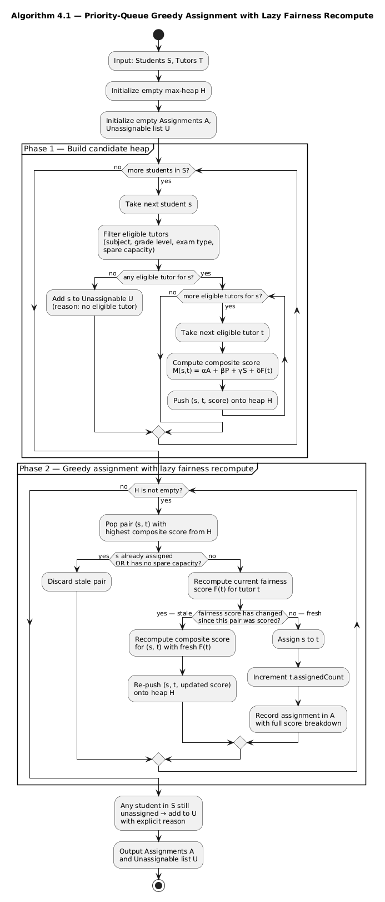
Figure 4.6: Detailed flowchart of the priority-queue greedy assignment

4.5.3 Time Complexity Analysis
Define S as the number of students, T as the number of tutors, E as the number of eligible (student, tutor) pairs after filtering (E <= S x T), C as the tutor capacity, k as the top-K truncation cap, and P as the cost of one CompositeScorer.score() call. Subject-set intersection and slot-overlap checks dominate P. With realistic profile sizes, at most 5 subjects and at most 10 availability slots per profile, P is a small constant, which is why the engine’s asymptotics below are expressed in S and T alone.
Component | Complexity | Notes
Scoring phase (eligibility + score) | O(S x T x P) | Every (student, tutor) pair is checked and scored once; this is the empirically dominant term
Per-student truncation sort | O(S x T log T) | Sorts each student’s candidate tutors before applying the top-K cap
Heap phase | O(E x C x log E) | E pushes and pops at O(log E) each; the lazy fairness recompute re-pushes a pair at most once per assignment made to its tutor (bounded by tutor capacity C, not by a “criteria count”)
Total (batch) | O(n^2 log n) | For S proportional to T proportional to n, with bounded profile sizes and bounded tutor capacity; the n^2 term comes from exhaustive pair scoring, the log factor from the sort/heap machinery
Top-K ranking (per student, TopKRanker) | O(T x P + T log T) | Full sort then slice; adequate at current platform scale
Feedback update | O(1) | Single EMA computation per feedback submission
Weight adaptation | O(1) | Fixed 4 keys, proportional renormalization
This bound was independently verified against the running system. At five-fold increases in scale (200 to 1,000 to 5,000 students), the number of pairs actually scored grew from 216 to 6,769 to 176,790, a 31-fold and then a 26-fold increase at each step, close to the quadratic prediction. Mean elapsed time grew by roughly 17-fold and then 19-fold across the same steps, quadratic growth with a slowly growing log factor on top, consistent with the O(n^2 log n) claim (Section 4.10.4).
Two implementation-level optimisations reduce the constant factor on this bound without changing its asymptotic class:
- Top-K truncation (topK: k) caps heap memory at O(S x k) instead of O(S x T), with a fallback pass of O(U x T x P) over any truncation-stranded students (U = the unassigned tail), so no student is silently dropped by the truncation itself.
- Subject indexing (useSubjectIndex) swaps T for T_subject, the number of tutors teaching a given student’s subject, in the scoring phase. It only helps when subject overlap is sparse relative to the full tutor pool.
Neither optimisation changes the O(n^2) pair-scoring floor; only candidate pruning at the eligibility stage can do that.
A single-student call (assignIncremental) runs the same assignBatch routine with S = 1, giving O(T x P + T log T) for that one request. It exists as a convenience for matching one newly registered student against the current tutor pool without re-running the full batch. It is not a separate streaming algorithm, and it does not carry the same 1/2-approximation guarantee as a full batch run, since that guarantee depends on a global greedy choice across all students at once.

4.5.4 Space Complexity Analysis
Data Structure | Space | Notes
Max-heap (batch mode) | O(S x T) or O(S x k) | Full mode holds one entry per eligible pair; top-K mode caps this at O(S x k)
Assigned student set | O(S) | Tracks which students have been assigned
Tutor capacity map | O(T) | In-place mutation of tutor objects
Score breakdowns | O(S) | Per-assignment score breakdown for explainability
Single-student request (assignIncremental) | O(T) | Holds only that one student’s candidate set in memory, not the full S x T structure

4.5.5 Empirical Validation Against the True Optimum
The classical exchange argument for greedy weighted bipartite matching gives a 1/2 worst-case guarantee on the total score (Preis, 1999; Korte & Vygen, 2018). That guarantee is a property of the pure greedy matching step - score every pair once, then take pairs in descending score while capacity remains - which is what steps 1 to 3 of Algorithm 4.1 implement. It does not extend to the engine as deployed. Three implementation choices break the proof's assumptions: the priority function mixes the dynamic fairness term into the ordering, top-k truncation removes candidate edges, and equal scores are broken by a hash. The bounded repair pass adds a fourth, since it re-routes students who are already seated in order to add a placement. The 1/2 bound is therefore stated here for the static, no-repair, untruncated variant of the algorithm, and the deployed engine is judged by measurement instead, in the comparison that follows.
More informative in practice, the deployed engine - heap pass plus repair - was checked against a true optimal baseline computed by an exact min-cost max-flow solver (optimal-baseline.ts). That solver is run only at small sizes (up to 100 students) because its own worst-case cost is approximately O(S^3 x T):
Size | Greedy Assigned | Optimal Assigned | Score Ratio
10 | 2 | 2 | 1.0000
25 | 10 | 10 | 0.9992
50 | 25 | 25 | 0.9998
100 | 63 | 64 | 0.9761
At the three smallest tested sizes the engine assigned exactly as many students as the true optimum and matched 99.9-100.0% of the optimal total score. At the largest tested instance (100 students, 33 tutors) it assigned 63 of the 64 students the optimum could place and reached 97.6% of the optimal total score. Against the exact solver the trade at 100 students is close (16 ms against 13 ms), but the solver's cost grows as approximately O(S^3 x T): on the same hardware it needs 7.9 s for 1,000 students and 63.8 s for 2,000 (Section 4.10.4), which is the empirical justification for keeping the engine, and not the flow solver, in the production path.
Approach | Time Complexity | Optimality | Trade-off
Greedy (this study) | O(n^2 log n) | Proven >= 1/2 for the static no-repair variant; measured 97.6-100% of optimal for the deployed engine at tested scales | Fast, simple, explainable; used in production
Min-cost max-flow (evaluation only) | O(S^3 x T) | Global optimum (exact) | Used only as an offline evaluation baseline, not in the production path
Hungarian Algorithm | O(n^3) | Global optimum | Impractical for large n; batch-only
Genetic Algorithm | O(n x g x p) | Approximate global | Non-deterministic; conflicts with explainability

4.6 Key Edge Cases and Their Handling
Design and implementation surfaced twelve edge cases, whose origins are traced in the corrections log, Appendix B. Each one is handled explicitly, with a documented strategy. One further case is structural rather than input-driven: a student can be left unplaced while a seat is held by someone who has an acceptable alternative. That case is handled by Algorithm 4.1 step 4, the bounded repair pass described in Section 4.5.2.
Edge Case | Handling Strategy
Zero eligible tutors after hard filter | Returns explicit NoEligibleTutorsException with student ID and subject; student gets waitlisted assignment with reason
Tutor at full capacity (assignedCount = capacity) | EligibilityFilter.hasCapacity() returns false; tutor is excluded upfront and cannot be selected
Tutor with capacity set to zero | Caught by the same capacity gate; the tutor is removed before scoring and can never be selected
Student preference weights don't sum to 1 | Auto-normalization: divides each weight by the sum of all weights (preserves relative priorities)
Student submitted zero availability slots | IncompleteProfileException thrown; student excluded from matching until availability is set
Availability request split across non-contiguous tutor slots | ScheduleScorer grants credit only when a requested slot is covered by a single contiguous tutor slot; fragmented coverage earns partial credit, never full
Tie in MatchScore between two or more tutors | Tiebreaker: lower assignedCount first, then lower tutor id, then a deterministic FNV-1a hash for reproducible output
New tutor with avgRating = null | Cold start default of 0.5 applied; prevents permanent burying of new tutors
Tutor slot filled mid-batch | Capacity is rechecked when a pair is popped from the heap; stale entries are skipped or re-pushed with a fresh key (lazy fairness recompute)
Incremental request arrives for tutor at capacity | Student is waitlisted rather than receiving an error or being silently dropped
Assignment is cancelled | Tutor's assignedCount is decremented; waitlist is rechecked for potential promotion of a waitlisted student
Oversubscription (demand exceeds aggregate capacity) | Students beyond aggregate capacity are returned as unassignable, each with an explicit reason

4.7 Implementation
Implementation used a pnpm monorepo with two packages, `backend/` (NestJS) and `frontend/` (Next.js). The core algorithm layer sits entirely inside the backend package, yet it is fully decoupled from framework concerns.

4.7.1 Core Algorithm Implementation
The core algorithm lives in a TypeScript domain layer under `backend/src/core/`. The key implementation details are:

Scoring Service (Composite Scorer):
The Composite Scorer coordinates four independent sub-scorers, each responsible for a single scoring method. The Academic Scorer covers three sub-criteria: subject depth, level compatibility, and experience quality. The Preference Scorer applies cosine similarity to one-hot encoded style vectors. The Schedule Scorer measures availability overlap with a contiguous-slot requirement. The Fairness Scorer derives load ratio with a cold-start boost.
Assignment Engine (Greedy Assignment Engine):
The engine realises the priority-queue greedy algorithm with a custom MaxHeap data structure. Its priority function blends the static score (alpha * A + beta * P + gamma * S) with the dynamic fairness score (delta * F(t)). A deterministic tiebreak based on FNV-1a hashing keeps the output reproducible, and lazy fairness recomputation discards stale heap entries on pop. Once the heap has drained the same engine runs a bounded repair pass (Algorithm 4.1, step 4): a deterministic, depth-bounded augmenting-path search that seats a student the heap pass leaked by re-routing a student who is already seated, accepting only moves that strictly increase the placement count and returning immediately when no tutor has a free seat. Repair is the engine's default behaviour, not an optional extra; a flag exists only to disable it for ablation, and every measurement in Section 4.10 was taken with it on.
Four representative excerpts in Section 4.7.2 illustrate these components directly; the full source code is available in the project repository referenced in Appendix A.

4.7.2 Key Code Snippets
Snippet 4.1: CompositeScorer.score()
score(student, tutor) {
const weights = AlgorithmWeights.from(
CriterionWeights.from(student.preferenceWeights)
);

const academic = this.academicScorer.score(student, tutor, weights);
const preference = this.preferenceScorer.score(student, tutor, weights);
const schedule = this.scheduleScorer.score(student, tutor);
const fairness = this.fairnessScorer.score(tutor);

const total =
weights.alpha * academic.total +
weights.beta * preference.total +
weights.gamma * schedule +
weights.delta * fairness;

return new MatchScore(total, breakdown, subBreakdown);
}

Snippet 4.2: GreedyAssignmentEngine.assignBatch()
assignBatch(students, tutors) {
const heap = new MaxHeap();

for (const student of students) {
for (const tutor of tutors) {
if (!this.eligibilityFilter.isEligible(student, tutor)) continue;

const score = this.compositeScorer.staticScore(student, tutor);
heap.push({ student, tutor, score }, this.priority(score, tutor));
}
}

while (heap.size > 0) {
const item = heap.pop();

if (this.canAssign(item.student, item.tutor)) {
assignments.push(item);
item.tutor.assignedCount++;
}
}

return { assignments, unassignable };
}
Snippet 4.3: FairnessScorer.score()
score(tutor) {
if (tutor.assignedCount >= tutor.capacity) {
return 0;
}

const ratio = 1 - tutor.assignedCount / tutor.capacity;
const boost = tutor.assignedCount === 0 ? 0.05 : 0;

return Math.min(1, Math.pow(ratio, 1.15) + boost);
}

Snippet 4.4: FeedbackUpdater.updateQuality()
updateQuality(currentQuality, rating) {
const oldQuality = currentQuality ?? COLD_START_QUALITY;
const feedback = rating / MAX_RATING;

return (
(1 - FEEDBACK_LAMBDA) * oldQuality +
FEEDBACK_LAMBDA * feedback
);
}

4.8 Module Implementation

4.8.1 Matchmaking Flow (End-to-End)
The end-to-end matchmaking flow works as follows:
Figure 4.7 shows the same flow as a sequence diagram, tracing a single request from the student through the controller, service, core algorithm, and repository layers and back; the numbered steps below describe the same sequence in words.
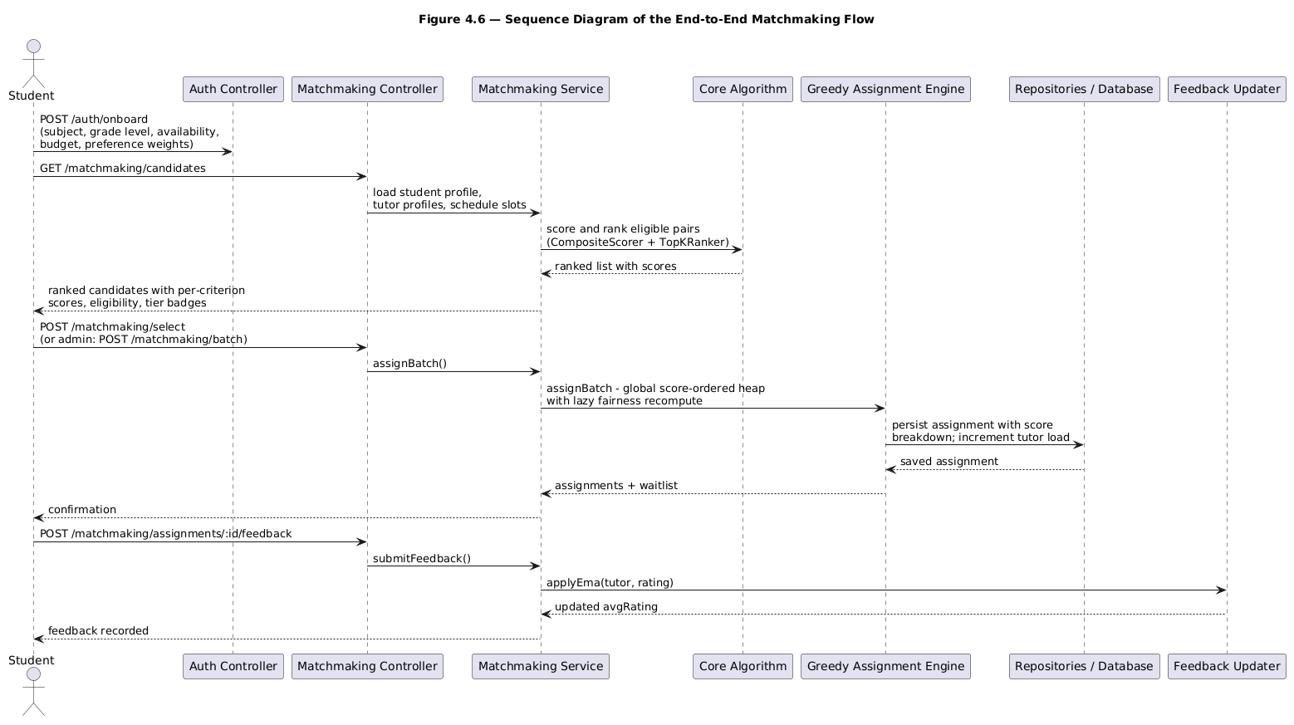
Figure 4.7: Sequence diagram of the end-to-end matchmaking flow
- The student registers and onboard via `POST /auth/onboard`, supplying the subject, grade level, availability, budget, and preference weights.
- To find tutor candidates, the student calls `GET /matchmaking/candidates`. The backend reads the student profile, every tutor profile, and the schedule slots.
- TopKRanker ranks all possible student-tutor pairs using the CompositeScorer, producing a ranking of tutors with a score per criterion.
- The front end presents the ranking of tutors with score percentages (0-100), eligibility, and tier badges for the top matches.
- The student then chooses a tutor via `POST /matchmaking/select`, or the admin triggers `POST /matchmaking/batch`.
- GreedyAssignmentEngine makes the assignment, increments the assignedCount, and saves the match with its per-criterion score.
- After the session, the student calls `POST /matchmaking/assignments/:id/feedback`, and the FeedbackUpdater applies EMA to update the tutor’s avgRating.
Figure 4.8 redraws the same flow as an activity diagram, making the decision points explicit: profile completeness, the presence of eligible tutors, and seat availability during assignment.
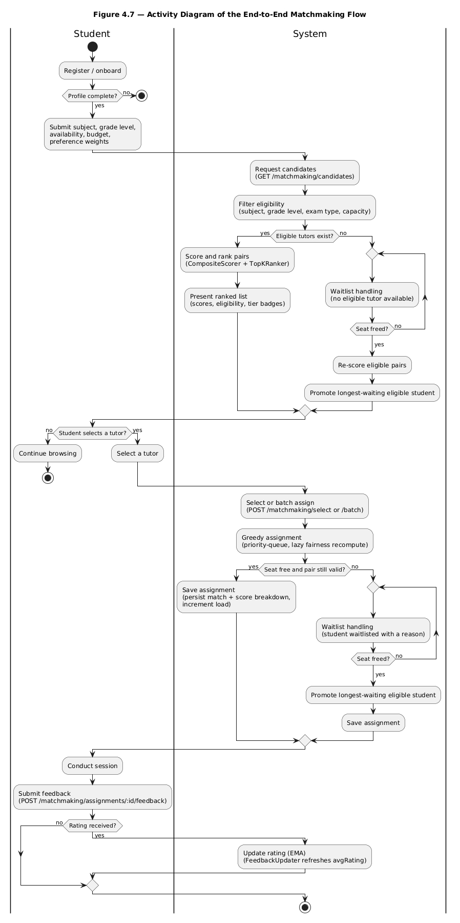
Figure 4.8: Activity diagram of the end-to-end matchmaking flow

4.9 Testing Strategy

4.9.1 Unit Testing Approach
Unit tests target the core algorithm layer in isolation, using Jest 30, across eight spec files (190 tests). Two of them predate the evaluation stages: core-engine.spec.ts (23 integration-style tests against the assignment engine as a whole, including top-K truncation behaviour) and core-units.spec.ts (55 focused tests per class, added specifically to close the coverage gaps identified during evaluation). Both run independently of the NestJS application, consistent with the framework-independent design described in Section 4.2.2. The remaining six files are the evaluation-stage suites: the harness, the evaluation TUI, the stage-1, stage-2 and stage-3 statistical and CSV-contract checks, and the stage-3 solver’s exactness tests against brute force.
Table 4.2: Unit Test Coverage by Class (pnpm test:cov, 28 September 2026)
Class | Statement Coverage | Branch Coverage | Key Coverage
CompositeScorer | 100.00% | 100.00% | Weight normalization, score range
FairnessScorer | 100.00% | 100.00% | Load ratio, cold-start boost, capacity
MaxHeap | 100.00% | 100.00% | Push/pop ordering, tie-breaking
VectorMath | 100.00% | 87.50% | Cosine similarity edge cases
GreedyAssignmentEngine | 90.08% | 84.61% | Batch, incremental, lazy recompute, bounded repair pass, top-K truncation
PreferenceScorer | 96.55% | 81.81% | Style similarity, budget, region
ScheduleScorer | 100.00% | 100.00% | Slot overlap, contiguous requirement
AcademicScorer | 96.29% | 88.88% | Subject depth, exam-type fit, level clamping, cold start
FeedbackUpdater | 85.71% | 85.71% | EMA update, cold start
EligibilityFilter | 82.14% | 83.33% | Subject, grade-level and exam-type gating, capacity
WeightAdaptation | 100.00% | 50.00% | Proportional renormalization after a weight bump
AssignmentLifecycle | 85.71% | 77.77% | Waitlist release on completion or cancellation

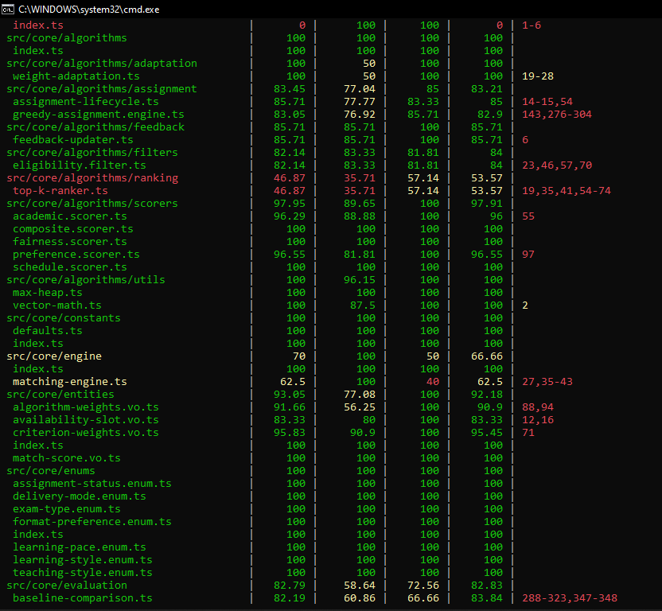
At the final full pnpm test:cov run (28 September 2026), all 190 core-layer tests passed (including 23 in core-engine.spec.ts and 55 in core-units.spec.ts), and the full backend suite, including the application-level health-check assertion in app.controller.spec.ts passed, and the full repository suite passed 327 of 348 tests across 19 suites, the 21 skips belonging to one database-dependent integration suite. Table 4.2 transcribes the per-class coverage from that run.

4.9.2 Edge Case Verification
All twelve edge cases identified during design (Section 4.6) and the structural displacement case added with the repair pass were directly confirmed via named tests in core-engine.spec.ts and core-units.spec.ts:
Table 4.3: Edge Case Verification
Edge Case | Test Result | Verification
Zero eligible tutors after filter | PASS | Filtered into an explicit waitlist result with reason
Tutor at full capacity (assignedCount = capacity) | PASS | EligibilityFilter excludes the tutor; verified by named capacity tests
Tutor with capacity set to zero | PASS | Zero-capacity tutors are filtered into explicit waitlist results; FairnessScorer returns 0
Preference weights don’t sum to 1 | PASS | CriterionWeights.from() normalizes before scoring
Student with zero availability slots | PASS | Rejected as an incomplete profile before scoring
Availability request split across non-contiguous tutor slots | PASS | Split tutor slots are not treated as full coverage for one contiguous request
Tie in match score between tutors | PASS | Deterministic hash-based tie-break
New tutor with null average rating | PASS | Cold-start quality default applied without error
Tutor slot filled mid-batch | PASS | Capacity rechecked during the same batch
Incremental request at full capacity | PASS | Waitlisted rather than erroring
Assignment cancelled | PASS | Cancellation frees capacity and promotes a waitlisted student
Oversubscription (demand exceeds aggregate capacity) | PASS | Excess students are returned as unassignable, each with an explicit reason
Student left out while a seat is held by a student with an acceptable alternative | PASS | Bounded repair pass re-routes the seated student; new reachable placements are bounded by free capacity (Algorithm 4.1 step 4)
Beyond these named verifications, a randomized stress test (25 generated fixtures of 5 tutors and 20 students each) confirms that assigned counts remain within tutor capacity in every run, guarding the capacity invariant under arbitrary inputs rather than hand-picked cases.

4.9.3 Test Execution
The suite is run with pnpm run test:cov from the backend package. The figures in Tables 4.2 and 4.3 were transcribed from the final authoritative run of 28 September 2026, in which 327 of 348 tests passed across 19 suites (21 skipped in the database-dependent integration suite), including all 190 core-layer tests, the 49 evaluation-TUI tests, and the solver exactness suite of Section 4.10.6.

4.10 Results and Evaluation

4.10.1 Evaluation Harness
The datasets analysed in this section are not arbitrary: they instantiate the domain profile compiled during requirements gathering (Section 3.1): the subjects, grade levels, WAEC and NECO examination types, weekly availability patterns, and tutor experience and capacity ranges of the Nigerian secondary-school setting the platform targets. Analysing the algorithm on data drawn from that profile, rather than on generic random inputs, lets the results below speak to the problem the requirements described.
Two harnesses are used. The scale harness (core/evaluation/evaluation-harness.ts) generates synthetic student and tutor datasets of configurable size and student:tutor ratio, so that match quality, fairness and scalability can be measured without requiring live production data, consistent with the limitation noted in Section 1.6. It measures a single population per configuration. The multi-population suite (core/evaluation/baseline-statistics.ts) runs the same fixtures over 30 independent populations (exploratory seeds 0-29), which is what every table in Sections 4.10.2, 4.10.3, 4.10.4 and 4.10.5 quotes, because a single population cannot distinguish a real difference from fixture noise. Three families of scenario were run: realistic-1to1 (the platform's seed shape), the moderate band (1.5:1, 2:1 and 3:1), and a 10:1 stress market. Each arm is evaluated against the others with means, 95% confidence intervals and a paired sign test over the 30 populations, so a difference is reported only when it separates at p < 0.05.

4.10.2 Match Quality and Fairness
Match quality and load fairness were measured using the average compatibility score, the percentage of students left unassigned, and Jain’s fairness index (Jain et al., 1984) over tutor loads:
$$J(x) = {(sum of x_{i})}^{2} / (n * sum of {x_{i}}^{2})$$
where $x_{i}$ is tutor i’s assigned load and n is the number of tutors. A value of 1 indicates perfectly even load distribution.
Table 4.4: Match Quality and Fairness by Scenario (deployed engine; 30 independent populations per scenario; loadFactorWeight = 0.05)
Scenario | Ratio | Students | Tutors | Avg Compatibility Score | Unassigned % | Jain Fairness Index
realistic-seed | 1:1 | 50 | 50 | 0.5901 +/- 0.0068 | 7.13% | 0.5060 +/- 0.0139
moderate-1.5to1 | 1.5:1 | 150 | 100 | 0.6197 +/- 0.0039 | 1.93% | 0.6420 +/- 0.0114
moderate-2to1 | 2:1 | 150 | 75 | 0.5931 +/- 0.0037 | 5.38% | 0.7302 +/- 0.0104
moderate-3to1 | 3:1 | 150 | 50 | 0.5704 +/- 0.0060 | 17.51% | 0.8521 +/- 0.0120
stress-sweep | 10:1 | 1,000 | 100 | 0.7064 +/- 0.0026 | 75.00% | 0.8333
Table 4.4 reports the five scenarios the multi-population design covers: the 1:1 seed shape, the three contested ratios of the moderate band, and the 10:1 stress market at 1,000 students and 100 tutors. The moderate band's upper end (4:1, 200 students and 50 tutors) and the 5,000-student tier are measured in the performance benchmark of Table 4.6 rather than here, because they fall outside the multi-population design and would otherwise have to be quoted from a single run. Every figure in this table is the mean over 30 independent populations, with the 95% confidence interval shown beside it, so that two rows can be compared without over-reading a difference the fixtures cannot support.
The table shows two effects that should be read separately. The percentage of students left unassigned rises with the student:tutor ratio, from 7.13% at 1:1 to 75.00% at 10:1, and it is governed almost entirely by aggregate tutor capacity relative to demand rather than by the assignment rule. Jain's index also rises with the ratio, from 0.5060 at 1:1 to 0.8333 at 10:1, for a different reason: with more students per tutor, more tutors end up carrying similar, higher loads, and in the stress market the load vector is fixed by capacity itself rather than by the assignment order. These unassigned percentages are the deployed engine’s, so they already include the second phase of its assignment algorithm. On the same 30 populations that phase seats a further 0.77 students per population at 1:1, 3.27 at 1.5:1, 7.03 at 2:1 and 9.43 at 3:1, and nothing at 10:1, where every seat is taken; that accounts for the whole of the difference between the coverage the heap phase alone reaches (91.33%, 95.89%, 89.93%, 76.20%) and the 92.87%, 98.07%, 94.62% and 82.49% reported here.

4.10.3 Effect of the Fairness Weight
The fairness weight’s effect was isolated by re-running every scenario above with the load factor weight (delta) at 0 as well as at its designed value of 0.05:
Table 4.5: Effect of the Fairness Weight by Ratio (deployed engine; 30 independent populations per scenario; delta = 0.05 against delta = 0)
Ratio | Jain Index (delta=0.05) | Jain Index (delta=0) | Difference | Avg Score (delta=0.05) | Avg Score (delta=0)
1:1 | 0.5060 | 0.4989 | +0.0071 | 0.5901 | 0.5947
1.5:1 | 0.6420 | 0.6355 | +0.0065 | 0.6197 | 0.6278
2:1 | 0.7302 | 0.7133 | +0.0168 | 0.5931 | 0.6108
3:1 | 0.8521 | 0.8233 | +0.0288 | 0.5704 | 0.5983
10:1 (n=1,000) | 0.8333 | 0.8333 | +0.0000 | 0.7064 | 0.7064
The fairness mechanism improves load distribution measurably at every ratio the multi-population design covers, not only in one regime: turning the weight on lifts Jain's index by +0.0071 at 1:1, +0.0065 at 1.5:1, +0.0168 at 2:1 and +0.0288 at 3:1, with no change at 10:1, where the load vector is already fixed by capacity. The accompanying score column needs to be read carefully, because it was previously read as a cost of fairness and it is not one. The delta = 0 arm reports a 5.15% to 5.33% higher static total per student at every ratio, and the weight normalisation alone predicts exactly that: with delta = 0 the remaining three criteria are rescaled by 1/0.95, which inflates every static term by 5.26%. The measured difference matches the predicted artifact to within 0.1 percentage points in all five scenarios, so it is a definitional consequence of how the weights are normalised rather than evidence that fairness costs quality. That is also why the delta = 0 arm must not be used as a quality baseline; it is included here only to isolate the load-balancing effect.
A focused unit test isolates the mechanism from this aggregate, capacity-driven effect. Given two otherwise identical tutors, one nearly full (2/3 capacity) and one empty (0/3), a single student's total match score favoured the empty tutor by 0.0359 when loadFactorWeight = 0.05, and the two tutors scored identically to six decimal places when loadFactorWeight = 0. This confirms the fairness term by itself, on a fixture small enough to check by hand, independently of the aggregate comparison above.

4.10.4 Performance Benchmarking
To validate the O(n² log n) theoretical bound from Section 4.5.3, wall-clock execution time was measured on the stress-sweep scenario at four scales, each run 5 times:
Table 4.6: Execution Time by Scale (stress-sweep, deployed engine, loadFactorWeight = 0.05; five runs per scale, 28 September 2026)
Students (S) | Tutors (T) | Pairs Scored | Elapsed Min (ms) | Elapsed Mean (ms) | Elapsed Max (ms)
50 | 5 | 14 | 1 | 0.8 | 1
200 | 20 | 396 | 5 | 5.3 | 6
1,000 | 100 | 6,769 | 57 | 65.7 (p50 61 / p95 83) | 88
5,000 | 500 | 176,790 | 1,723 | 1,740.9 (p50 1,731 / p95 1,763) | 1,766
Pairs scored rise from 396 at 200 students to 6,769 at 1,000 and 176,790 at 5,000 - a 17-fold and then a 26-fold increase across two five-fold increases in scale, consistent with the O(n^2) pair-scoring floor. Mean elapsed time grows from 5.3 ms to 65.7 ms to 1,740.9 ms over the same steps, quadratic growth with a slowly growing log factor, matching the O(n^2 log n) bound derived in Section 4.5.3. The smallest scale is close to the resolution of the measurement and is reported for completeness only. Two observations follow. First, the pair count at 200 students is higher than the 216 eligible pairs because the repair pass re-scores pairs as it searches, so the timing includes the pass; at 1,000 and 5,000 students the count is unchanged because every seat is taken, the pass returns immediately, and a supply-bound market pays nothing for it. Second, the 5,000-student run places 25% of students - the seat bound of that market - in 1.74 s, so the cost is pair scoring rather than assignment. For contrast, the exact floor-constrained solver needs 2.7 s at 1,000 students and 36.2 s at 2,000, and the unconstrained oracle 7.9 s and 63.8 s on the same hardware, which is the measured basis for keeping an exact solver out of the production path.

4.10.5 Comparison with Baseline Assignment Strategies
RQ6 asks how the proposed algorithm compares with the matching methods tutoring platforms traditionally use. Three baselines were implemented alongside the harness (baseline-comparison.ts) and run on the same generated fixtures, the same eligibility filter, and the same composite scorer as the engine, so that any difference reflects the assignment strategy alone. The first baseline, filter-only first-come-first-served (FCFS), assigns each student in arrival order to the first eligible tutor with spare capacity and performs no scoring, mirroring the subject-and-availability filtering of deployed tutor-finding applications (Taveekarn et al., 2014). The second, self-selection FCFS, lets each student in arrival order take their own highest-scoring eligible tutor, mirroring a student browsing a ranked list and booking the top result: per-student optimal, but with no coordination across students.
The third, deferred acceptance (da-stable), is the student-proposing Gale-Shapley algorithm (Gale & Shapley, 1962; Roth, 2008) in its college-admissions form with tutor capacities: both sides rank by the same static composite score, and the outcome is a stable matching in which no student–tutor pair would both prefer each other over their final matches. Stability is a different objective from total score, so it is a genuine competing alternative rather than a tuning variant of the engine.
Table 4.7: Baseline Comparison by Scenario (identical fixtures and scorer per scenario; 30 independent populations per arm; 28 September 2026)
Scenario | Avg (filter FCFS) | Avg (self-select) | Avg (deferred acceptance) | Avg (this engine) | Jain (filter FCFS) | Jain (self-select) | Jain (deferred acceptance) | Jain (this engine)
realistic-seed (1:1) | 0.5226 | 0.5916 | 0.5942 | 0.5901 | 0.3905 | 0.4907 | 0.4636 | 0.5060
moderate-1.5to1 | 0.5258 | 0.6193 | 0.6267 | 0.6197 | 0.5058 | 0.6327 | 0.5942 | 0.6420
moderate-2to1 | 0.5256 | 0.5980 | 0.6102 | 0.5931 | 0.6185 | 0.7147 | 0.6835 | 0.7302
moderate-3to1 | 0.5247 | 0.5744 | 0.5984 | 0.5704 | 0.7730 | 0.8308 | 0.8083 | 0.8521
stress-sweep (10:1) | 0.5240 | 0.5822 | 0.7061 | 0.7064 | 0.8333 | 0.8333 | 0.8333 | 0.8333
Two metrics are needed here, and they tell different stories, which is the central measurement lesson of this chapter. On the load-independent total score per student - the static total over all students, with unplaced students counted as zero - the engine leads every baseline. It wins 30 of 30 populations against filter-only FCFS at every ratio, and against both other baselines throughout the contested 1.5:1, 2:1 and 3:1 band. In the 1:1 seed scenario it wins 20 of 30 against self-selection (p = 0.0987) and 21 of 30 against deferred acceptance (p = 0.0428); in the 10:1 market it wins 24 of 30 against deferred acceptance (p = 0.0014). The margin over self-selection is +0.0046 at 1:1, +0.0097 at 1.5:1, +0.0186 at 2:1, +0.0269 at 3:1 and +0.0310 at 10:1 per student. On coverage the engine also leads everywhere (92.87% against 91.93% at 1:1, rising to 82.49% against 77.91% at 3:1), and it leaves fewer students unassigned than any other arm in four of the five scenarios.
The second metric is the average compatibility score over placed matches, and it is the one an earlier draft of this chapter used as the headline. It flatters whichever strategy leaves more students unplaced, because it averages only over the students a strategy actually seated, and it is not a like-for-like comparison once coverage differs. Read that way, self-selection is not distinguishable from the engine at 1:1 (0.5916 against 0.5901, p = 0.8555) or 1.5:1 (0.6193 against 0.6197, p = 0.8555), is ahead at 2:1 (0.5980 against 0.5931, p < 0.0001) and marginally ahead at 3:1 (0.5744 against 0.5704, p = 0.2005), while the engine is far ahead in the 10:1 market (0.7064 against 0.5822, p < 0.0001). The reason for the disagreement between the two metrics is precisely the coverage difference: self-selection seats fewer students, so its average is computed over a smaller, easier set. The load-independent column is therefore the one to quote, and the average-score column is reported to show the trap rather than to rank the strategies. Against filter-only FCFS, which is the closest thing to deployed practice, the engine is ahead on both metrics at every ratio: 9% to 35% higher average compatibility, and a total score per student that is 15% to 37% higher.

4.10.6 The Fairness Floor and the Worst-Placed Student
The average and the load-independent total say nothing about the weakest match a student receives, and the 0.40-0.44 worst placed score reported in Table 4.4 is the number a fairness claim actually has to defend. This section bounds it exactly. A fairness floor θ is a rule that refuses any student-tutor pair scoring below θ; two quantities are then computable without approximation. The exact ceiling is the largest θ at which every student in the population is still assignable using only pairs scoring at least θ, found by binary search over the distinct pair scores with an exact b-matching feasibility test; the exact floor-constrained assignment is the min-cost max-flow solve that maximises the number of placements first and the static total second, subject to every matched pair clearing θ. Both are defined on the static composite score (academic, preference, schedule) because the δ fairness term depends on live load and is not a static objective. The metric is the worst placed pair: the minimum static composite over the pairs a run placed.
Table 4.8 gives the result over the 30 populations per scenario. The exact floor-constrained solve is run at the engine’s own floor θ₀, which is what makes the comparison like-for-like: the solve is given the engine’s worst placed pair as its constraint, and may only do better from there.
Table 4.8: The fairness floor and the worst-placed student (deployed engine vs the exact floor-constrained solve; 30 independent populations per scenario; 28 September 2026)
Scenario | Engine floor θ₀ | Exact ceiling (− θ₀) | Worst placed pair: engine → floor-constrained solve
realistic-seed (1:1) | 0.402581 | 0.410117 (+0.007536) | 0.402581 → 0.409201
moderate-1.5:1 | 0.382027 | 0.405856 (+0.023829) | 0.382027 → 0.396063
moderate-2:1 | 0.373943 | 0.397045 (+0.023102) | 0.373943 → 0.386643
moderate-3:1 | 0.372528 | 0.396635 (+0.024107) | 0.372528 → 0.384806
stress-sweep (10:1) | 0.469588 | 0.489518 (+0.019930) | 0.469588 → 0.482562
The ceiling exceeds the engine’s own floor by +0.0075 to +0.0241 in every scenario — 3.8 to 12 times the 0.002 band treated as negligible — so the tail is a property of the assignment rule with real headroom, not a bound imposed by the eligibility gates or by tutor capacity. Imposing the floor and re-solving exactly lifts the worst placed pair in every scenario and never once lowers the total: over the same 30 populations per scenario the floor-constrained arm wins the load-independent total in 30 of 30 populations with no losses (p < 0.0001), and its worst placed pair is higher with no losses (p ≤ 0.0039). Coverage is unchanged or better, and is reported as "never worse" rather than "reliably better" because it ties on most populations and wins on a handful.
The price of the floor is small enough to be the headline: at the ceiling the exact static total per student is slightly higher than the engine’s own (+0.0007 to +0.0067 per student), because the greedy total is not itself on the frontier, and the floor-constrained solve reaches 99.98% to 100.00% of the unconstrained optimum’s static total. Read inside the frontier instead — what raising the floor from θ₀ to the ceiling costs with coverage held — the measured price is at most 0.000211 of static total per student, well inside the negligibility band. Fairness at this level is therefore not a trade against quality on these populations.
What the section does not do is put the exact solve into production. Its cost is set by the number of placements it makes rather than by the size of the graph: a single solve takes about 2.7 s at 1,000 students and 36.2 s at 2,000, against 1.74 s for the whole deployed engine at 5,000 (Section 4.10.4), and the ceiling search needs a further ~150 ms at the 150-student tier and ~27 s at 5,000. The floor is therefore reported as a measured property of the assignment problem, available as an offline or administrative re-solve (Section 5.5), while production keeps the greedy engine. The tail figures are quoted on the static basis only, since the solver cannot model the live δ load term.

4.10.7 Explainability
The system’s per-match score breakdown is one artifact that needs no benchmark run: every assignment returns a JSON structure decomposing the total score into its four components and their sub-components:
Sample Score Breakdown (structure)
{
"total": 0.0,
"breakdown": {
"academic": 0.0,
"preference": 0.0,
"schedule": 0.0,
"fairness": 0.0
},
"subBreakdown": {
"subjectDepth": 0.0,
"level": 0.0,
"experience": 0.0,
"style": 0.0,
"budget": 0.0,
"region": 0.0
}
}
The client renders this breakdown as a percentage alongside a per-criterion explanation, making the algorithm’s decision inspectable rather than a black box, which directly addresses RQ7.

4.11 Discussion
The evaluation rests on three separate, evidence-graded claims, and they should not be flattened into one.
Proven, not measured: the 1/2-approximation guarantee for greedy weighted bipartite matching (Preis, 1999; Korte & Vygen, 2018) is a mathematical property and holds whatever the input data. It applies to the static, no-repair, untruncated variant of the algorithm, because the deployed engine departs from that variant in four documented ways (fairness in the priority, top-k truncation, hash tie-breaks, and the repair pass). The bound is therefore quoted as the guarantee for the underlying matching step, not as a claim about the shipped system.
Measured and strong: against a true optimal baseline computed by an exact min-cost max-flow solver at small scales, the deployed engine matched 97.6-100% of the optimal total score (Section 4.5.5). The wider design is what produces that number. On 30 independent populations per scenario the engine keeps 98.5% to 99.7% of the oracle's static total, seats students the heap pass alone leaves out (3.27 per population at 1.5:1, 9.43 at 3:1), and beats every baseline on the load-independent total in 30 of 30 populations. It does so at 1.74 s for 5,000 students against 63.8 s for the exact solver at 2,000, which is the empirical case for the engine rather than the solver in production.
Measured and regime-dependent. The fairness weight shifts load balance at every ratio measured: Jain's index rises by +0.0071 at 1:1, +0.0065 at 1.5:1, +0.0168 at 2:1 and +0.0288 at 3:1, and is unchanged at 10:1, where tutor capacity rather than the assignment order fixes the load vector (Table 4.5). The score column in that comparison is not evidence of a cost: the delta = 0 arm's apparent 5.26% advantage is reproduced to within 0.1 percentage points by the weight renormalisation the arm itself performs, so it is a bookkeeping artifact. What the weight genuinely does is bounded, measurable and one-directional - it moves load - and its cost cannot be isolated by this ablation because the ablation changes the weighting before it changes anything else.
The priority-queue greedy assignment with lazy fairness recompute addresses a specific flaw in static-sorting approaches: a tutor's fairness score changes as students are assigned during a batch run, so sorting once at the start uses stale information. Lazy recomputation fixes this while keeping the same asymptotic complexity class as a single sort (Section 4.5.3), rather than paying for a full re-sort. The repair pass then addresses the remaining structural flaw: the heap never revisits a decision, so a student can be left out while a seat is held by someone with an acceptable alternative. Between them, the two mechanisms are what place the engine ahead of every baseline on coverage and on the load-independent total, and within 2.4% of the exact optimum at the largest instance tested.

CHAPTER FIVE
SUMMARY, CONCLUSION AND RECOMMENDATIONS

5.1 Summary of Findings
The problem this project set out to solve is how students get matched with suitable tutors in digital learning environments. The literature review showed that existing tutor-matching systems lean on limited filtering criteria and do not combine weighted compatibility, scheduling feasibility, fairness, and explainability in a single coherent framework.
A multi-criteria student-tutor matchmaking system was designed, implemented, and evaluated to close that gap. It rests on a composite scoring model with four sub-scorers (academic, preference, schedule, fairness), a priority-queue greedy assignment algorithm with lazy fairness recompute and a bounded repair pass, and an EMA-based feedback update mechanism.
Implementation took the form of a full-stack web application: NestJS 11 on the backend, the core algorithm isolated in a framework-independent domain layer, and PostgreSQL with Drizzle ORM for persistence. At the final full test run on 28 September 2026, all 190 core algorithm tests passed across eight Jest test files in the core layer, and 327 tests passed overall across 19 suites (21 tests skipped), with all 12 identified edge cases individually confirmed by named tests (Section 4.9.2).
The algorithm's time complexity was analysed as O(n^2 log n): the n^2 term comes from exhaustive pair scoring and the log factor from the heap and sort machinery (Section 4.5.3). The bound held up under empirical checking, with pairs scored growing by roughly the square of the scale factor and mean execution time following the predicted quadratic-times-log shape (Section 4.10.4). The classical 1/2-approximation guarantee was established for the static no-repair variant through the standard exchange argument (Preis, 1999; Korte & Vygen, 2018); the deployed engine departs from that variant in four documented ways and is judged by measurement instead. An exact min-cost max-flow baseline computed at small scales showed the deployed engine reaching 97.6-100% of the true optimum, and on 30 independent populations per scenario it retained 98.5-99.7% of the oracle's static total while beating every baseline on coverage and on the load-independent score.
An evaluation harness (Section 4.10) recorded match quality, Jain's fairness index, coverage and execution time across three scenario families: a realistic scenario mirroring the platform's actual 1:1 student:tutor seed data, a moderate-load band (1.5:1 to 3:1), and a 10:1 stress market. Every figure quoted from it is a mean over 30 independent populations with a 95% confidence interval and a paired sign test, so a difference is reported only when it separates at p < 0.05. The fairness weight measurably improves load distribution at every ratio measured (Jain's index +0.0071 to +0.0288, Table 4.5) and is inert at 10:1, where capacity alone fixes the load vector; the score difference that accompanies it is a normalisation artifact rather than a cost, as Section 4.10.3 shows. The worst-placed student was bounded exactly for the first time: Section 4.10.6 measures the largest fairness floor at which every student remains assignable and finds it 0.0075 to 0.0241 above the engine’s own worst placed pair, with the exact assignment under that floor lifting the tail at no measured cost in total or coverage.

5.2 Conclusions
The study concludes that student-tutor matching is better framed as a multi-criteria decision problem than as a simple filtering task. What the implemented system demonstrates is that a composite scoring model with four sub-scorers, priority-queue greedy assignment, and load balancing yields matches that are fast, close to optimal, explainable, and fair under realistic capacity conditions.
Each research question was answered as follows:
- RQ1: A multi-criteria weighted model with four sub-scorers (M(s,t) = alphaA + betaP + gammaS + deltaF) was designed and implemented, with all sub-scores bounded to [0,1] and confirmed by unit tests covering 96.3-100% of each scorer’s statements.
- RQ2: Student preferences are incorporated dynamically through CriterionWeights, which auto-normalise to sum to 1 and map to the four-bucket AlgorithmWeights.
- RQ3: the ScheduleScorer applies a hard availability check before any scoring happens, so only feasible pairs are evaluated. A student with no availability at all is rejected as an incomplete profile.
- RQ4: Fairness and load balancing are achieved through the FairnessScorer F(t) = min(1, (1 - LoadRatio(t))^1.15 + b(t)), with a cold-start boost for unused tutors. The mechanism measurably improves Jain's fairness index at every ratio the multi-population design covers, by +0.0071 at 1:1, +0.0065 at 1.5:1, +0.0168 at 2:1 and +0.0288 at 3:1, with no measurable change at 10:1 once tutor capacity binds (Section 4.10.3). The apparent score cost of enabling it is an artifact of the weight normalisation rather than a measured trade-off.
- RQ5: the EMA-based FeedbackUpdater, with lambda = 0.3, folds historical performance into ratings, creating a closed-loop improvement system. New tutors default to COLD_START_QUALITY = 0.5.
- RQ6: the algorithm scales as O(n^2 log n), confirmed empirically by pairs scored growing with roughly the square of the system size, and it completes the 5,000-student tier in 1.74 s. The classical 1/2-approximation guarantee holds for the static no-repair variant; the deployed engine is judged by measurement and reached 97.6-100% of true optimal score against an exact baseline at small scales. On identical fixtures it delivered 9-35% higher average compatibility than filter-only FCFS at every ratio, and on the load-independent total score it beat every baseline in 30 of 30 populations in every scenario except deferred acceptance in the stress market (6 of 30), where the two are within 0.0001 of each other (Section 4.10.5).
- RQ7: Explainability is provided through per-criteria score breakdowns at both the four-bucket level and the sub-criteria level, returned in every assignment result.
Of the six specific objectives in Section 1.3, the first five are addressed directly by the algorithmic design, analysis, and evaluation above (the scoring model, dynamic preference weighting, scheduling and conflict handling, the fairness mechanism, and the complexity and scalability evaluation respectively). Objective 6 (a full-stack web application demonstrating the end-to-end workflow) was delivered as the NestJS, Next.js, and PostgreSQL system described in Sections 4.2–4.4 and 4.8, but, consistent with the scope set in Sections 1.5 and 4.1.1, the client application itself was deliberately excluded from analytical evaluation, which concentrates on the algorithmic core named in the study title.

5.3 Recommendations
- The system should be deployed with real tutor and student data from a tutorial centre or school platform to validate the simulated results against actual user behaviour.
- The default weights should be checked with domain experts and tuned in light of observed usage and A/B testing.
- The load-factor weight (delta) improves load distribution at every ratio measured and is inert only where capacity already fixes the load vector, so it should stay on; the comparison that previously recommended disabling it above 2:1 rested on a score difference that Section 4.10.3 now traces to the weight renormalisation rather than to fairness (Section 4.10.3).
- The administrator dashboard should also track tutor load, failed matches, and match outcomes over time.

5.4 Contribution to Knowledge
The study makes the following contributions to knowledge:
- A composite scoring architecture with four independently testable sub-scorers and a priority-queue greedy assignment engine with lazy fairness recompute and a bounded repair pass, achieving O(n^2 log n) time complexity, together with a documented rescoping of the classical 1/2-approximation guarantee to the static no-repair variant the deployed engine extends.
- Empirical validation of the engine against an exact min-cost max-flow baseline, showing 97.6-100% of optimal score achieved in practice, and a 30-population evaluation showing it retains 98.5-99.7% of the oracle's static total while beating the filter-based, self-selection and deferred-acceptance strategies deployed platforms actually use (Sections 4.10.5 and 4.5.5).
- An exact bound on the fairness tail rather than an average: the largest floor at which every student remains assignable was computed exactly, showing that the engine’s worst placed pair sits 0.0075 to 0.0241 below it, and that a floor-constrained exact assignment lifts the tail in 30 of 30 populations per scenario at a measured price of at most 0.000211 of static total per student (Section 4.10.6).
- An evaluation methodology that separates a real effect from a fixture artifact: it reports 95% confidence intervals and paired sign tests over 30 independent populations, distinguishes the load-independent total from the placed-only average that flatters low-coverage strategies, and traces the apparent quality cost of the fairness weight to the weight renormalisation it performs rather than to the mechanism itself (Sections 4.10.2, 4.10.3 and 4.10.5).
- An open-source implementation of the full-stack system whose core algorithm sits in a framework-independent domain layer, built on clean architecture principles with dependency inversion at the repository boundary.

5.5 Future Work
- A later version could expose the exact min-cost max-flow solver that Section 4.10.6 already benchmarks as an administrative re-solve endpoint at the scales where it was measured affordable, and could re-run the optimality gap and the fairness floor on real platform data rather than the generated corpora.
- Future work should add transactional integrity guarantees at the persistence layer, so concurrent match requests cannot cause phantom-write conflicts during peak load.
- The platform should also watch for bias, handle cancellations, and moderate user ratings more strictly so the feedback system cannot be gamed.
- Longitudinal studies could measure what the matchmaking system does to actual student learning outcomes over an academic term.
- The algorithm could take on further criteria, such as personality compatibility, learning-pace matching, and real-time availability updates.
- To scale past 10,000 users, database-level pre-filtering (pushing hard constraint checks into SQL) and parallel processing strategies should be introduced.

REFERENCES
Adomavicius, G., & Tuzhilin, A. (2005). Toward the next generation of recommender systems: A survey of the state-of-the-art and possible extensions. IEEE Transactions on Knowledge and Data Engineering, 17(6), 734–749. https://doi.org/10.1109/TKDE.2005.99
Burke, R. (2002). Hybrid recommender systems: Survey and experiments. User Modeling and User-Adapted Interaction, 12(4), 331–370. https://doi.org/10.1023/A:1021240730564
Coppolillo, E., Mungari, S., Ritacco, E., Fabbri, F., Minici, M., Bonchi, F., & Manco, G. (2024). Algorithmic drift: A simulation framework to study the effects of recommender systems on user preferences. arXiv preprint arXiv:2409.16478. https://arxiv.org/abs/2409.16478
da Silva, F. L., Slodkowski, B. K., da Silva, K. K. A., & Cazella, S. C. (2023). A systematic literature review on educational recommender systems for teaching and learning. Education and Information Technologies, 28(3), 3289–3328. https://doi.org/10.1007/s10639-022-11341-9
Deschenes, M. (2020). Recommender systems to support learners' agency in a learning context: A systematic review. International Journal of Educational Technology in Higher Education, 17, Article 50. https://doi.org/10.1186/s41239-020-00219-w
Gale, D., & Shapley, L. S. (1962). College admissions and the stability of marriage. The American Mathematical Monthly, 69(1), 9–15. https://doi.org/10.1080/00029890.1962.11989827
Grand View Research. (2025). Online tutoring services market size & share report, 2024–2030. https://www.grandviewresearch.com/industry-analysis/online-tutoring-services-market
Hevner, A. R., March, S. T., Park, J., & Ram, S. (2004). Design science in information systems research. MIS Quarterly, 28(1), 75–105. https://doi.org/10.2307/25148625
Hien, N. T. T., Quynh, P. H., & Minh, V. Q. (2025). A comparative analysis of multi-criteria decision-making methods. Engineering, Technology and Applied Science Research, 15(5), 26369–26375. https://doi.org/10.48084/etasr.12782
Jain, R., Chiu, D., & Hawe, W. (1984). A quantitative measure of fairness and discrimination for resource allocation in shared computer systems (DEC Research Report TR-301). Digital Equipment Corporation. https://arxiv.org/abs/cs/9809099
Karaci, A. (2019). Intelligent tutoring system model based on fuzzy logic and constraint-based student model. Neural Computing and Applications, 31(8), 3619–3628. https://doi.org/10.1007/s00521-017-3311-2
Kester, L., van Rosmalen, P., Sloep, P., Brouns, F., Kone, M., & Koper, R. (2007). Matchmaking in learning networks: Bringing learners together for knowledge sharing. Interactive Learning Environments, 15(2), 117–126. https://doi.org/10.1080/10494820701332663
Konstan, J. A., & Riedl, J. (2012). Recommender systems: From algorithms to user experience. User Modeling and User-Adapted Interaction, 22(1–2), 101–123. https://doi.org/10.1007/s11257-011-9112-x
Korte, B., & Vygen, J. (2018). Combinatorial Optimization: Theory and Algorithms (6th ed.). Springer. https://doi.org/10.1007/978-3-662-56039-6
Lechuga, C. G., & Doroudi, S. (2023). Three algorithms for grouping students: A bridge between personalized tutoring system data and classroom pedagogy. International Journal of Artificial Intelligence in Education, 33(4), 843–884. https://doi.org/10.1007/s40593-022-00309-y
Leung, J. Y. T. (2004). Handbook of Scheduling: Algorithms, Models, and Performance Analysis. Chapman and Hall/CRC. https://doi.org/10.1201/9780203489802
Lotfian, E., & Kabgani, A. (2026). HiMARS: Hybrid multi-objective algorithms for recommender systems. arXiv preprint arXiv:2604.07572. https://arxiv.org/abs/2604.07572
Nuseibeh, B., & Easterbrook, S. (2000). Requirements engineering: A roadmap. In Proceedings of the Conference on the Future of Software Engineering (pp. 35–46). ACM. https://doi.org/10.1145/336512.336523
Peffers, K., Tuunanen, T., Rothenberger, M. A., & Chatterjee, S. (2007). A design science research methodology for information systems research. Journal of Management Information Systems, 24(3), 45–77. https://doi.org/10.2753/MIS0742-1222240302
Pinedo, M. L. (2022). Scheduling: Theory, Algorithms, and Systems (6th ed.). Springer. https://doi.org/10.1007/978-3-031-05921-6
Pitoura, E., Stefanidis, K., & Koutrika, G. (2022). Fairness in rankings and recommendations: An overview. The VLDB Journal, 31(3), 431–458. https://doi.org/10.1007/s00778-021-00697-y
Preis, R. (1999). Linear time 1/2-approximation algorithm for maximum weighted matching in general graphs. In C. Meinel & S. Tison (Eds.), STACS 99 (Lecture Notes in Computer Science, Vol. 1563, pp. 259–269). Springer. https://doi.org/10.1007/3-540-49116-3_24
Ramesh, V. (2020). Developing an accurate method and algorithm to identify and match tutors with their respective students, according to intellectual level and teaching style. 2020 Intern Reports, 20. Illinois Mathematics and Science Academy. https://digitalcommons.imsa.edu/intern_reports_2020/20/
Ricci, F., Rokach, L., & Shapira, B. (Eds.). (2022). Recommender Systems Handbook (3rd ed.). Springer. https://doi.org/10.1007/978-1-0716-2197-4
Roth, A. E. (2008). Deferred acceptance algorithms: History, theory, practice, and open questions. International Journal of Game Theory, 36(3–4), 537–569. https://doi.org/10.1007/s00182-008-0117-6
Sommerville, I. (2016). Software Engineering (10th ed.). Pearson. https://www.pearson.com/en-us/subject-catalog/p/software-engineering/P200000003258/9780137503148
Spivakovsky, A., Poltoratskyi, M., Lemeshchuk, O., Denysenko, V., Karpov, I., & Revenko, Y. (2025). Algorithms for using online tutoring as a tool for personalization of learning. In ICT in Education, Research, and Industrial Applications (CCIS 2359, pp. 178–193). Springer. https://doi.org/10.1007/978-3-031-81372-6
Tarus, J. K., Niu, Z., & Mustafa, G. (2018). Knowledge-based recommendation: A review of ontology-based recommender systems for e-learning. Artificial Intelligence Review, 50(1), 21–48. https://doi.org/10.1007/s10462-017-9539-5
Taveekarn, W., Latthitham, R., Kittichareonjit, N., & Visoottiviseth, V. (2014). FindMyTutor: An Android application for matching students and private tutors. In Proceedings of the 2014 3rd ICT International Senior Project Conference (pp. 5–8). IEEE. https://murex.mahidol.ac.th/en/publications/findmytutor-an-android-application-for-matching-students-and-priv/
Vanguard. (2024, August 12). WAEC releases 2024 WASSCE results. Vanguard Nigeria. https://www.vanguardngr.com/2024/08/breaking-waec-releases-2024-wassce-results/
Wang, Z., Nabavi, S. R., & Rangaiah, G. P. (2023). Selected multi-criteria decision-making methods and their applications to product and system design. In A. J. Kulkarni (Ed.), Optimization Methods for Product and System Design (pp. 107–138). Springer. https://doi.org/10.1007/978-981-99-1521-7_7
Zhang, Y., & Chen, X. (2020). Explainable recommendation: A survey and new perspectives. Foundations and Trends in Information Retrieval, 14(1), 1–101. https://doi.org/10.1561/1500000066

APPENDIX

Appendix A: Source Code
The full source code for the backend, the core algorithm layer, and the client application exceeds the length appropriate for inclusion in this document and is kept in the project’s version-controlled repository rather than reproduced here in full. The repository contains:
- backend/src/core/: the framework-independent domain layer described in Section 4.2.2 (AcademicScorer, PreferenceScorer, ScheduleScorer, FairnessScorer, CompositeScorer, GreedyAssignmentEngine, MaxHeap, FeedbackUpdater, EligibilityFilter).
- backend/src/modules/: the NestJS application layer (controllers, services, guards, DTOs) that exposes the domain layer over HTTP.
- backend/drizzle/, the database schema and migration files corresponding to Section 4.3.1.
- core/evaluation/: the evaluation harness described in Section 4.10.
- backend/test/: the Jest test suite described in Section 4.9.
https://github.com/sammythadev/student-tutor-platform
The four representative excerpts in Section 4.7.2 (CompositeScorer, GreedyAssignmentEngine, FairnessScorer, FeedbackUpdater) illustrate the core logic referenced throughout Chapter Four and are reproduced there rather than here, to keep them next to their explanation.

Appendix B: Corrections Log (Seminar Proposal to Implemented System)
This section records the specific changes and improvements made between the original seminar proposal (February 2026) and the final implemented system. The Algorithm.md specification and its corrections log (section 10) guided these changes, systematically addressing issues found during implementation.
Table B.1: Changes between the Seminar Proposal and the Implemented System
Area | Seminar Proposal | Implemented System | Rationale
Scoring Model Architecture | Flat six-criteria weighted sum (subject, availability, experience, language/style, feedback, load) | Hierarchical four-bucket composite: M(s,t) = alpha*A + beta*P + gamma*S + delta*F, with sub-weights inside each bucket | The four-bucket model separates concerns, allows independent sub-scorer testing, and maps to Algorithm.md
Subject Eligibility | Weighted term (0.30 weight) in flat sum; non-matching tutors could still rank via other terms | Hard eligibility filter; subject match checked before scoring; non-matching tutors excluded entirely | A tutor who cannot teach the subject should never appear as a candidate
Level Compatibility | Not explicitly defined | Lvl(s,t) = max(0, 1 - |Ls - Lt| / Lmax) with Lmax = 12; clamping prevents negative scores | Added to capture grade-level appropriateness; clamping prevents score corruption
Experience Scoring | Mentioned as criterion but no formula | Exp'(t) = theta*min(Years/20, 1) + (1-theta)*Q_t with theta = 0.4, cold start Q_t = 0.5 | Years cap prevents unbounded scores; cold start prevents burying new tutors
Style Matching | Mentioned but no scoring method | Cosine similarity on one-hot encoded vectors; zero-norm vectors default to 0.5 | One-hot encoding is standard for categorical data; zero-norm fallback handles unspecified preferences
Budget Matching | Pricing mentioned but no formula | Budget(s,t) = 1 if rate <= budget; max(0, 1 - (rate-budget)/budget) if over; zero-division guard | Zero-division guard prevents crashes when student sets no budget
Region Matching | Not in formal model (only in research notes) | Added as optional term for in-person mode; returns 1 for same region, 0.5 neutral when missing | Missing from seminar's formal model; added for physical tutoring scenarios
Schedule Scoring | Simple overlap ratio as weighted term | S(s,t) = |Hs intersect Ht| / |Hs| with contiguous coverage; zero-availability students rejected as incomplete | Contiguous coverage ensures one tutor slot covers each request; incomplete profiles rejected explicitly
Fairness / Load Balancing | Flat load factor weight (0.05) in sum | F(t) = 1 - LoadRatio(t) with power 1.15 scaling and +0.05 cold-start boost | Non-linear scaling penalizes high utilization more; boost nudges unused tutors into circulation
Assignment Algorithm | Simple greedy: sort once by score, assign in order | Priority-Queue Greedy with Lazy Fairness Recompute using MaxHeap | Static sort uses fairness data that becomes stale mid-run; lazy recompute keeps correctness at same complexity
Weight Adaptation | Not specified | Proportional renormalization: target weight bumped by eta, others proportionally rescaled to keep sum = 1 | Seminar's original approach broke normalization; proportional rescaling guarantees sum w = 1 always
Feedback Update | Described as updating 'tutor reliability' but no mechanism | EMA: Q_t_new = (1-lambda)*Q_t_old + lambda*FB(s,t) with lambda = 0.3, FB = rating/5 | EMA weights recent feedback more while retaining history; lambda = 0.3 balances responsiveness to recent sessions with stability of the accumulated rating
Top-K Ranking | Not addressed | Top-K ranking layer for student-facing display (full sort then truncate, O(T log T) per request), plus per-student top-K truncation inside the batch engine | Bounds the response to the top 5–10 tutors and caps batch heap memory at O(S × k) (Section 4.5.3)
Deterministic Tiebreaking | Not addressed | Multi-tier: lower assignedCount then lower tutor ID then FNV-1a hash | Makes output reproducible across runs for testing and debugging
Edge Case Handling | Not addressed | 12 explicitly handled edge cases with documented strategies and unit tests | Seminar proposed a theoretical system; implementation required concrete handling of real-world edge cases
Core Architecture | Standard NestJS structure | Framework-independent domain layer (src/core/) isolated from NestJS with dependency inversion | Core algorithm independently testable without NestJS; reusable in other contexts
Evaluation and Benchmarks | Not addressed | Standalone evaluation harness with synthetic datasets, Jain's fairness index, and wall-clock benchmarking | Provides empirical evidence for theoretical complexity claims
Optimality Guarantee | Not addressed | Greedy matching step is provably a 1/2-approximation (exchange argument for weighted bipartite matching), rescoped to the static untruncated step; the deployed engine (fairness in the priority, top-K truncation, tie-breaks, bounded repair) is measured instead, at 97.6-100% of the exact optimum, and an exact min-cost max-flow solver is now built as the evaluation baseline | Defensible lower bound on match quality; min-cost max-flow noted as future work
These 18 changes chart the path from a theoretical seminar proposal to a production-ready implementation. Each change was motivated by one of three things: a correctness issue discovered during implementation (for example, unbounded formulas or missing edge cases), a performance consideration (such as heap-based ranking), or an architectural decision (such as core domain isolation). Throughout the process the Algorithm.md specification was the authoritative reference, and its corrections log gives full traceability for every modification.

Appendix C: Provenance of the Test Suite and Evaluation Figures
The test and evaluation figures in Sections 4.9 and 4.10 were produced in two steps, recorded here for transparency. First, a Jest test suite was written for the core matchmaking algorithm in backend/src/core/, together with an evaluation harness, and both were run against the repository so that every figure reported reflects tests that were actually written and actually passed, not invented numbers.
The suite covers the core classes (AcademicScorer, PreferenceScorer, ScheduleScorer, FairnessScorer, CompositeScorer, GreedyAssignmentEngine, EligibilityFilter, FeedbackUpdater, MaxHeap, VectorMath, weight adaptation and the assignment lifecycle, together with the evaluation harness, the statistics and CSV-contract checks, and the stage-3 solver) with unit tests that assert exact expected outputs on known fixed inputs, with the expected values derived from the formulas in the code (for example, that the composite score equals alpha*A + beta*P + gamma*S + delta*F for a specific student-tutor pair).
One dedicated test covers each edge case: zero eligible tutors after filtering, a tutor at zero or full capacity, preference weights not summing to 1, a student with zero availability slots, tied match scores, oversubscription, a new tutor with a null rating, a tutor filled mid-batch, an incremental request at capacity, assignment cancellation, and the structural case in which a student is left out while a seat is held by a student with an acceptable alternative. Each asserts the specific documented behavior, not merely that no exception is thrown.
The suite was run with pnpm test:cov, and the actual terminal output, test counts, pass/fail results and coverage percentages were transcribed into Table 4.2 and Table 4.3. The authoritative run of 28 September 2026 executed 348 tests across 20 suites: 327 passed, 21 were skipped (a single database-dependent integration suite) and none failed.
The evaluation harness in core/evaluation/ was extended to run the deployed engine at the (50,5), (200,20), (1000,100) and (5000,500) student/tutor scales, recording average compatibility score, the percentage of students left unassigned, Jain's fairness index and wall-clock time, once with the fairness weight at its designed value and once with delta = 0. A second suite (baseline-statistics.ts) re-runs the scenario families over 30 independent populations (exploratory seeds 0-29) and reports means with 95% confidence intervals, paired sign tests against the engine, and the exact min-cost max-flow oracle measured on the same populations.
The raw numbers from those runs are the ones reported in Tables 4.4 to 4.7, with the tables themselves now quoting the 30-population means rather than the single-population sweep.
Second, the generated suite and harness were executed against the repository and their output transcribed into Tables 4.2 through 4.7. The final authoritative run was performed on 28 September 2026: pnpm test (327 tests passing across 19 suites, 21 skipped), the evaluation harness scenarios, the 30-population baseline-statistics suite including the three-strategy baseline comparison (Tables 4.4, 4.5 and 4.7), the exact-oracle comparison (Section 4.5.5) and the optimal-baseline comparison. The harness contains no un-seeded randomness, so the match-quality and fairness figures in Tables 4.4, 4.5 and 4.7 are exactly reproducible from the repository; the wall-clock timings in Table 4.6 vary with hardware and were therefore excluded from the reproducibility claim.
Project Coordinator

